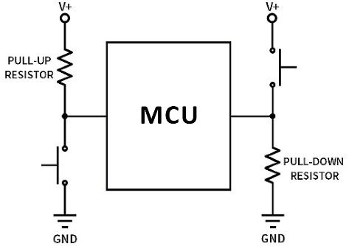 **Pull-up and pull-down circuits**

* Pull-up and pull-down circuits are used to ensure that

pins on a microcontroller have a known voltage level

before they are actively driven by other components.

**Liquid Crystal Display LCD**

LCD I2C (i²c)

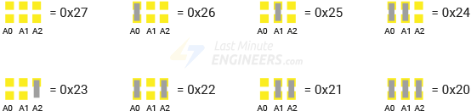i2c bridging connection charts

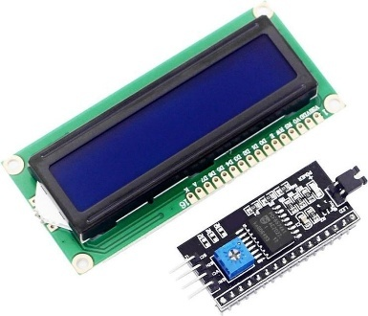

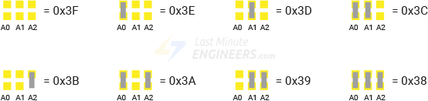

SetCursor (0,0)

|  |  |  |  |  |  |  |  |  |  |  |  |  |  |  |  |  |
| --- | --- | --- | --- | --- | --- | --- | --- | --- | --- | --- | --- | --- | --- | --- | --- | --- |
|  | 1 | 2 | 3 | 4 | 5 | 6 | 7 | 8 | 9 | 10 | 11 | 12 | 13 | 14 | 15 | 16 |
| 1 |  |  |  |  |  |  |  |  |  |  |  |  |  |  |  |  |
| 2 |  |  |  |  |  |  |  |  |  |  |  |  |  |  |  |  |

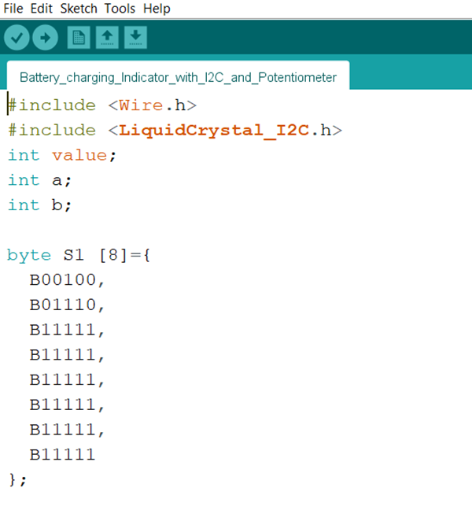

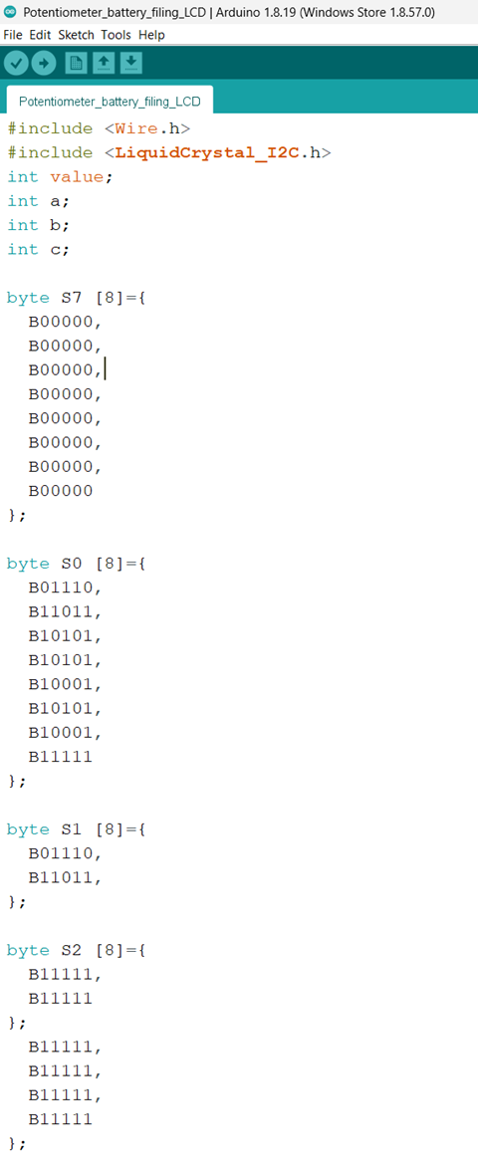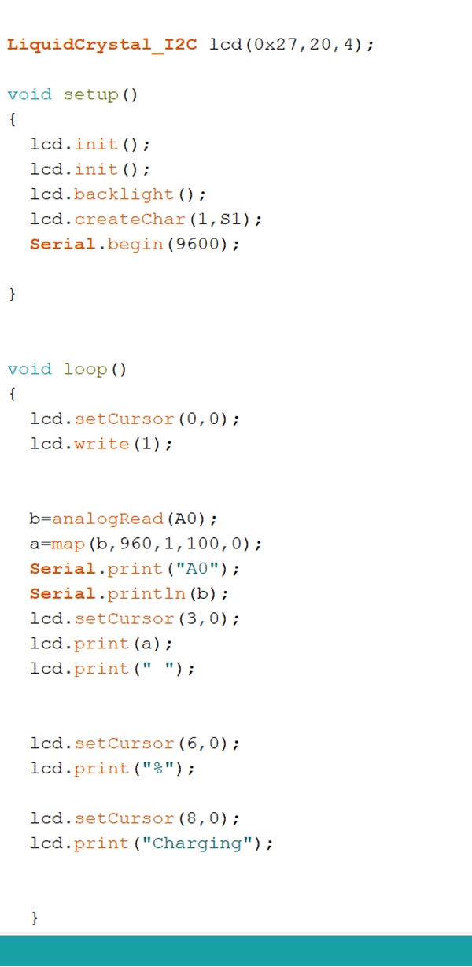

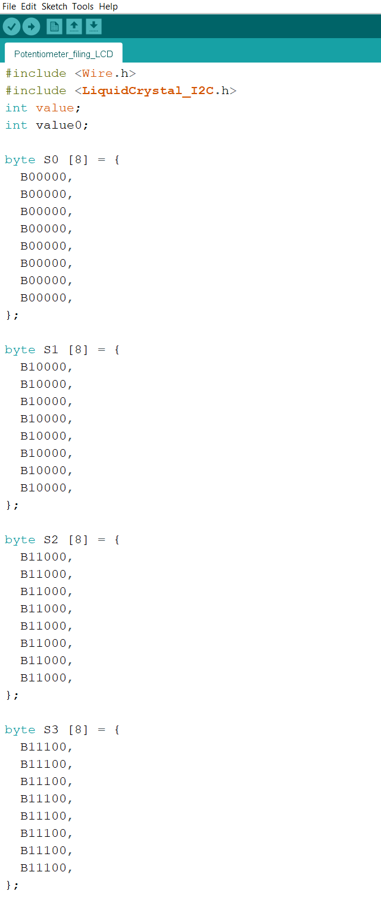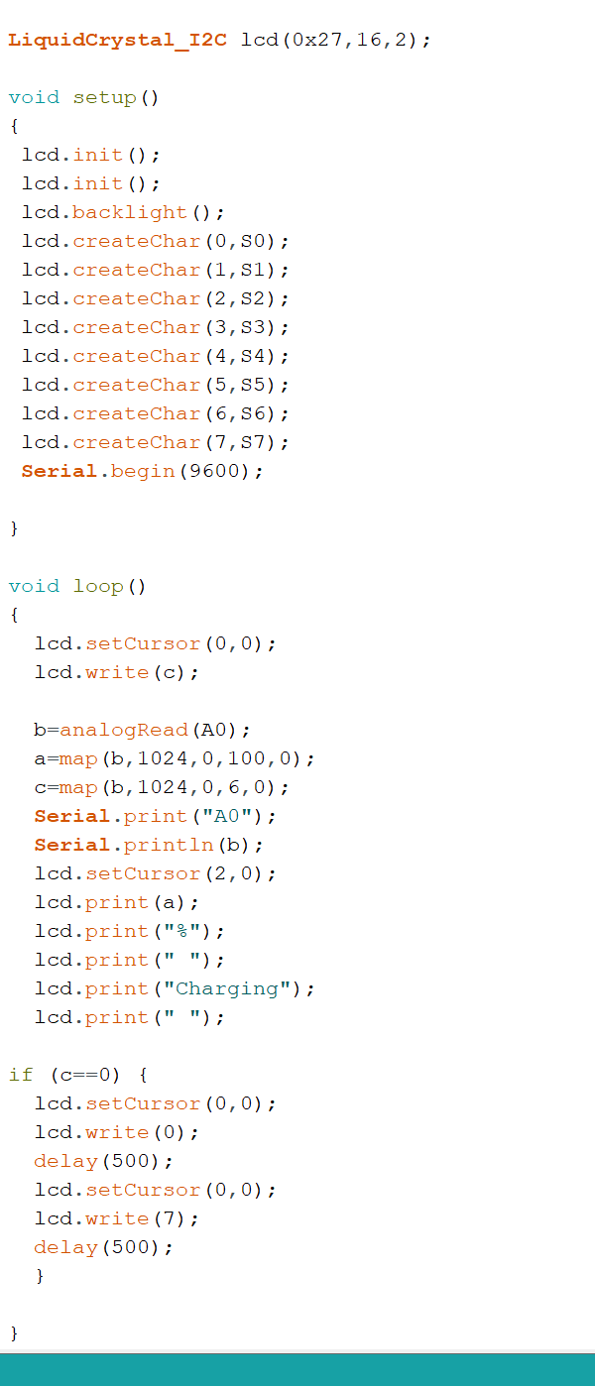

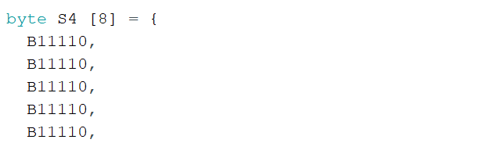

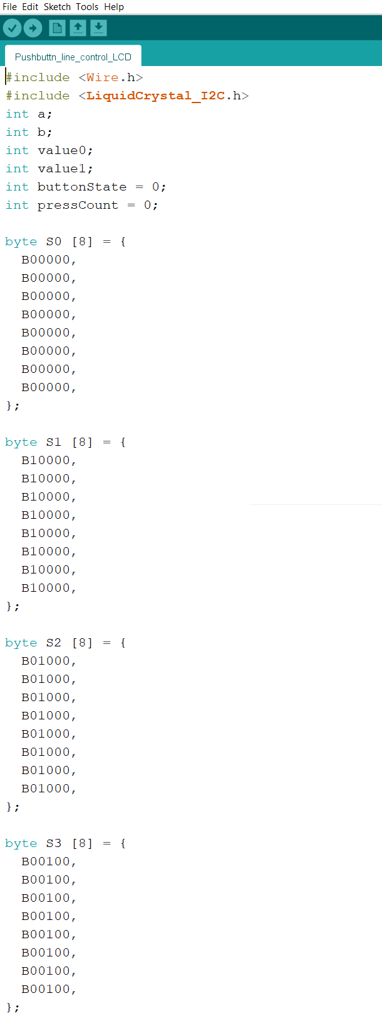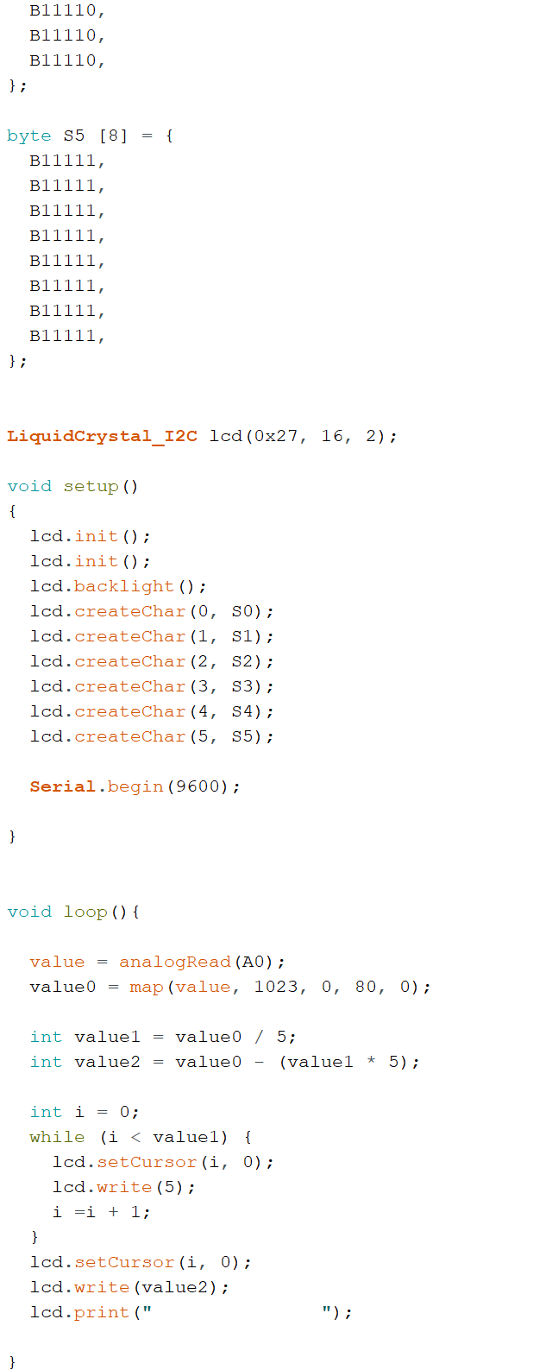



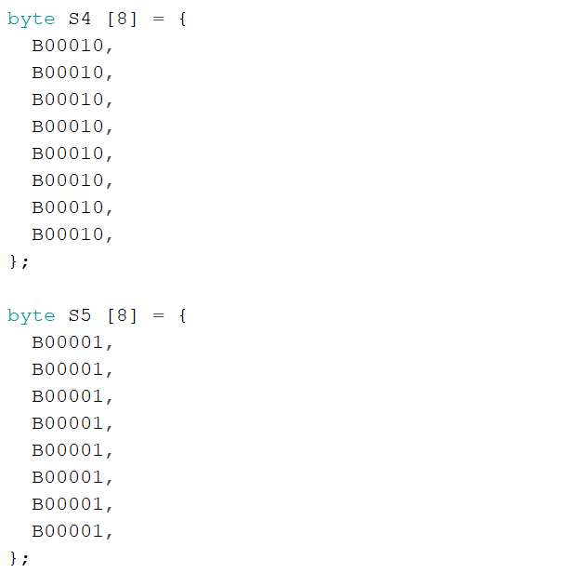

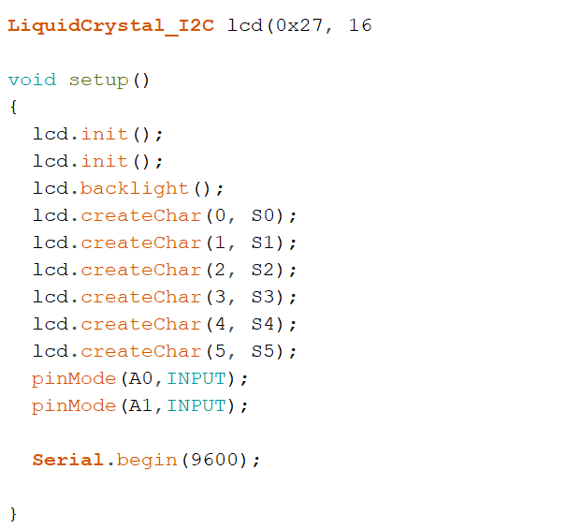

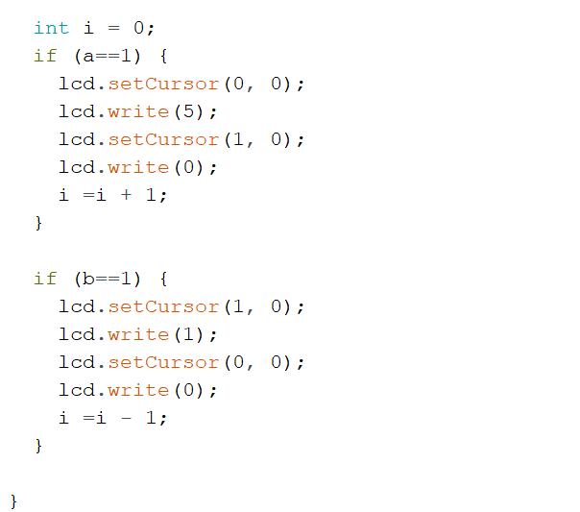

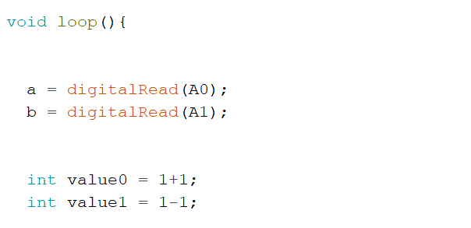



**Ultrasonic Sensor**

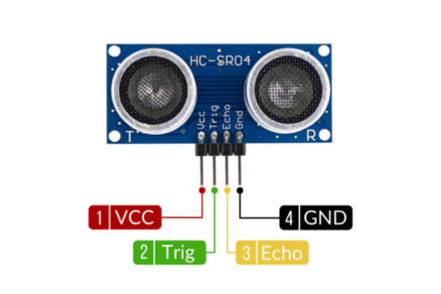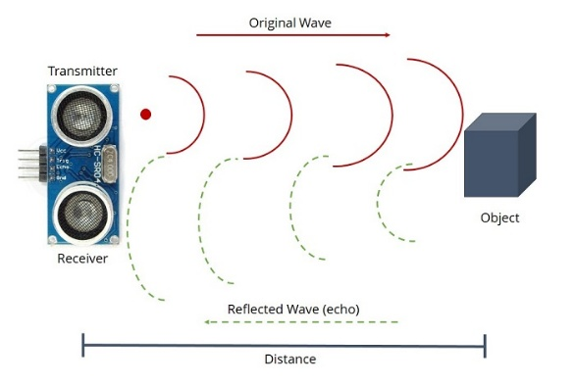

* Calculate the target’s distance by emitting ultrasonic sound waves and converting them

into electrical signals.

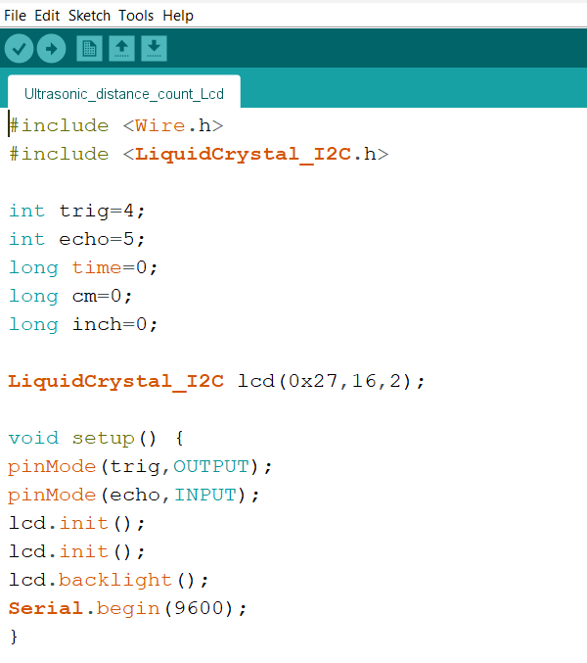

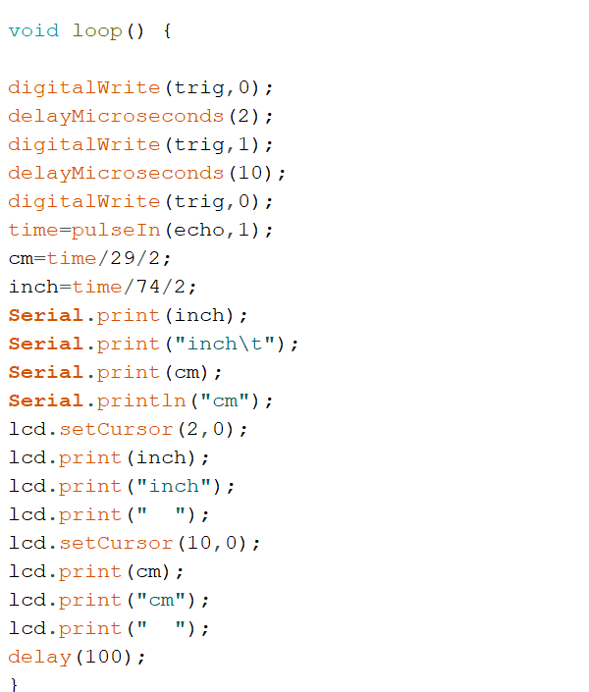



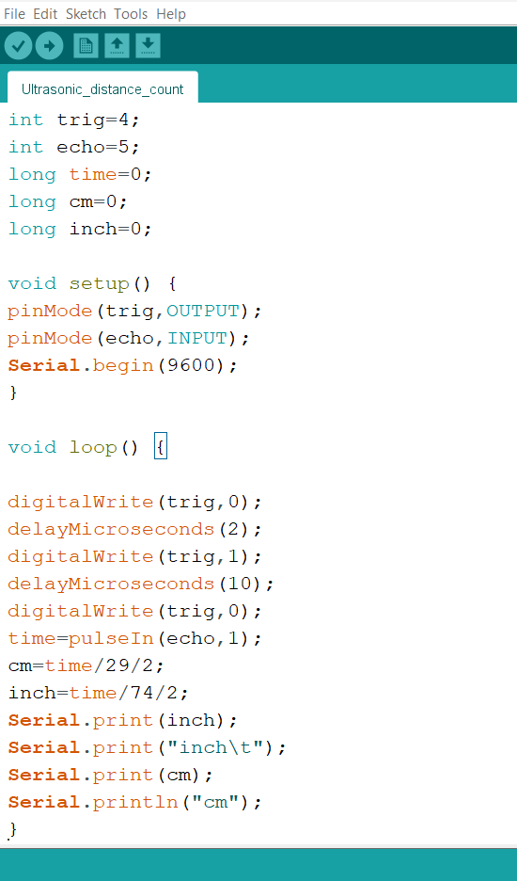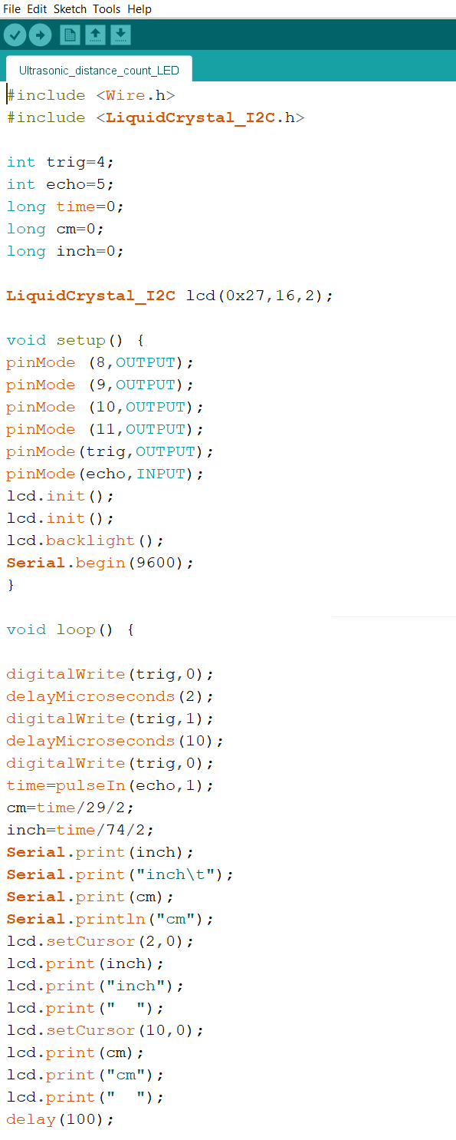

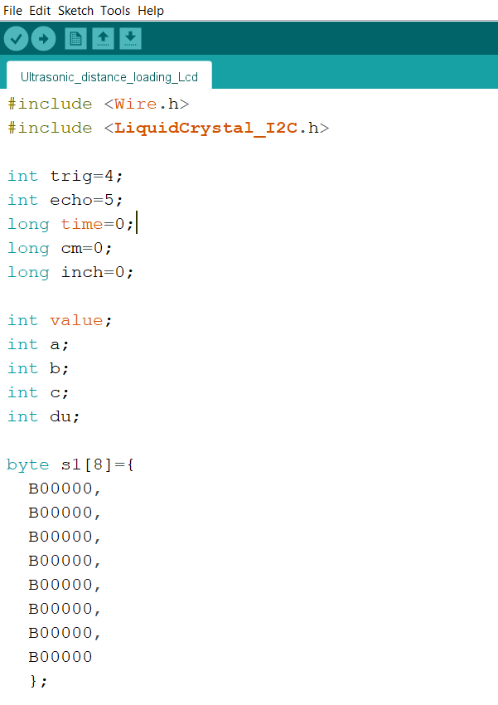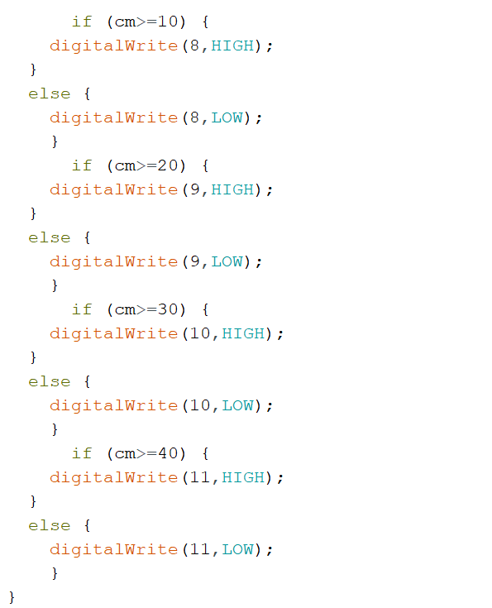



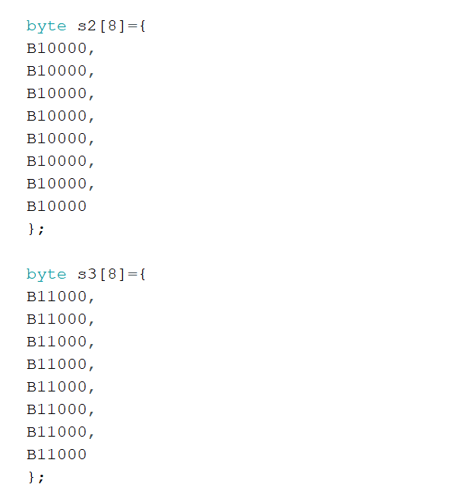

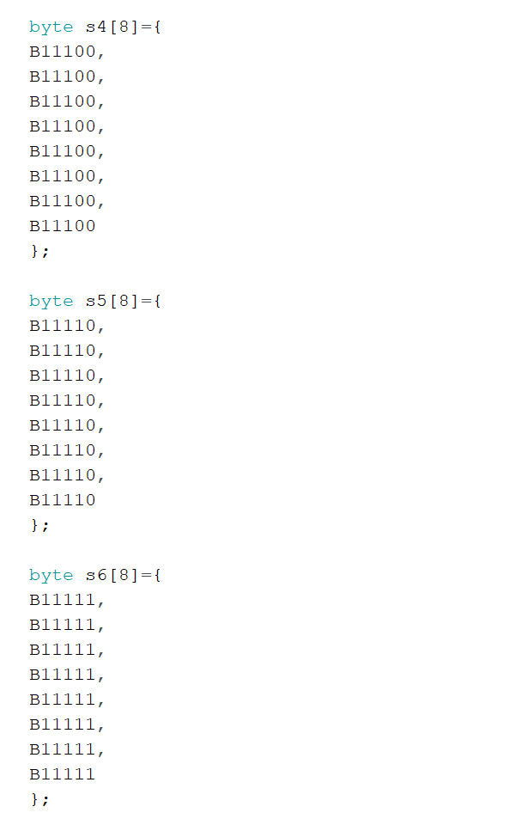

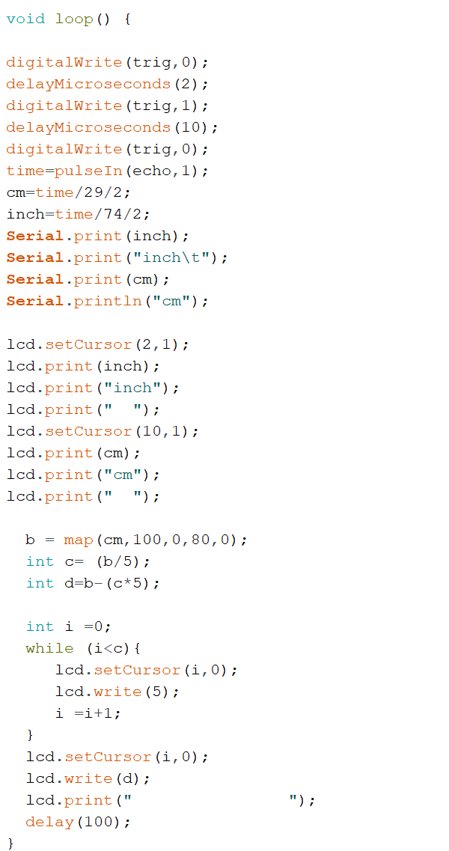

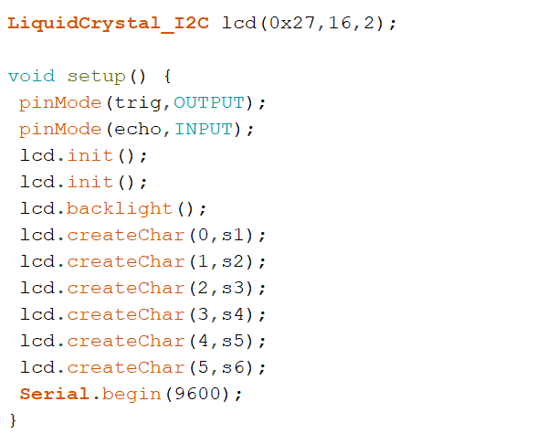



**Seven Segment Display**

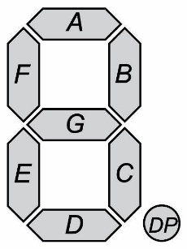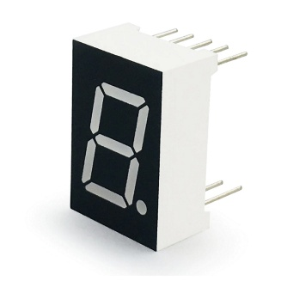

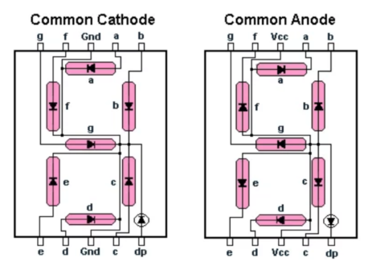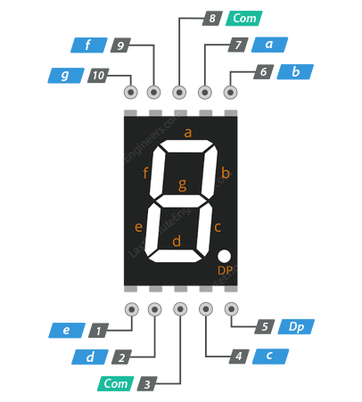

* Seven segment display is an electronic display device used to show decimal numbers from

0 to 9. It consists of seven segments.

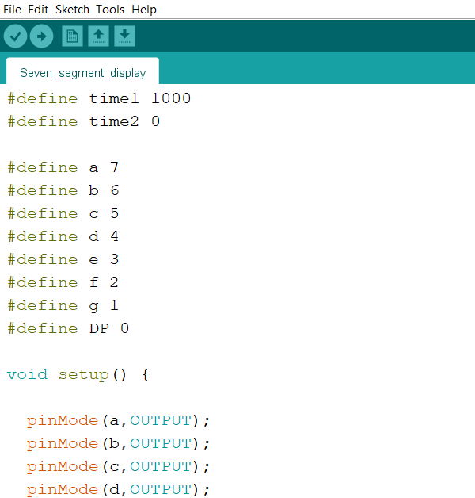

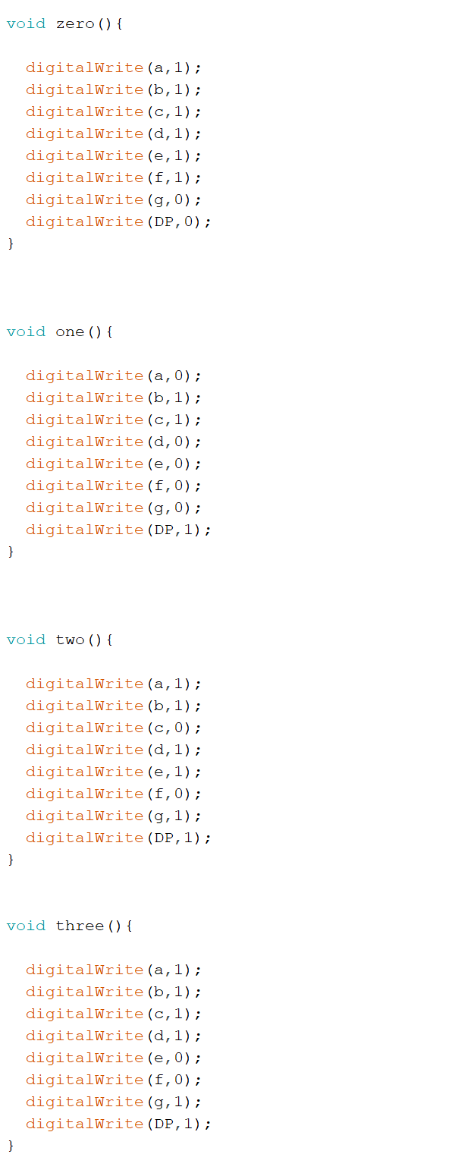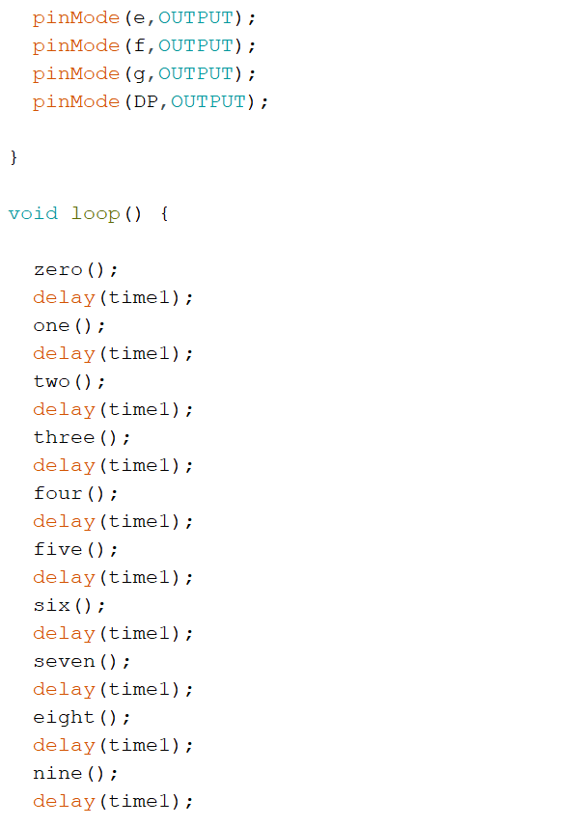

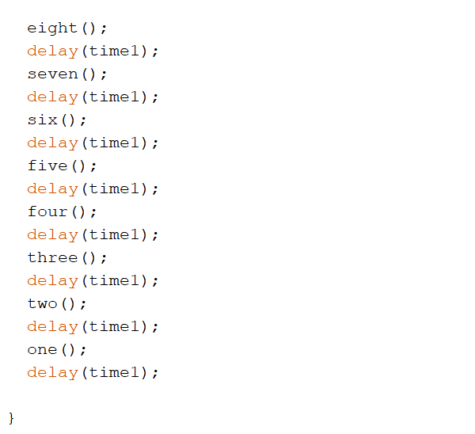

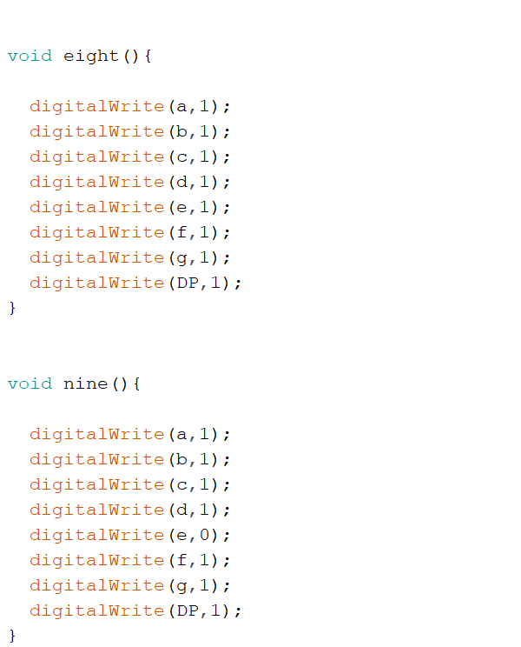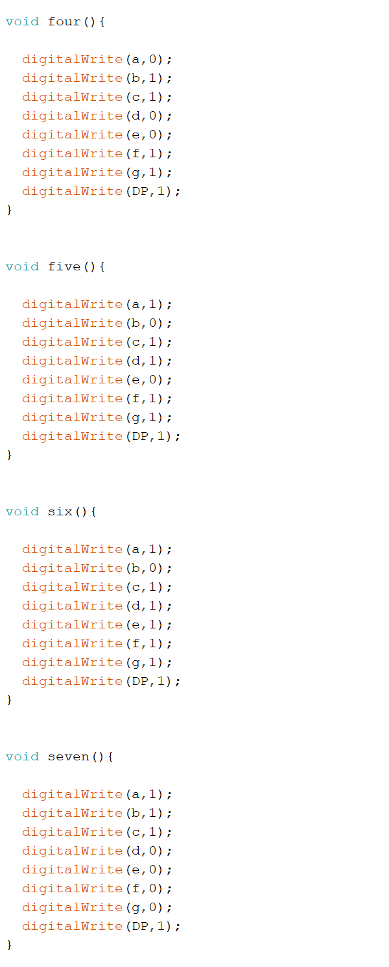

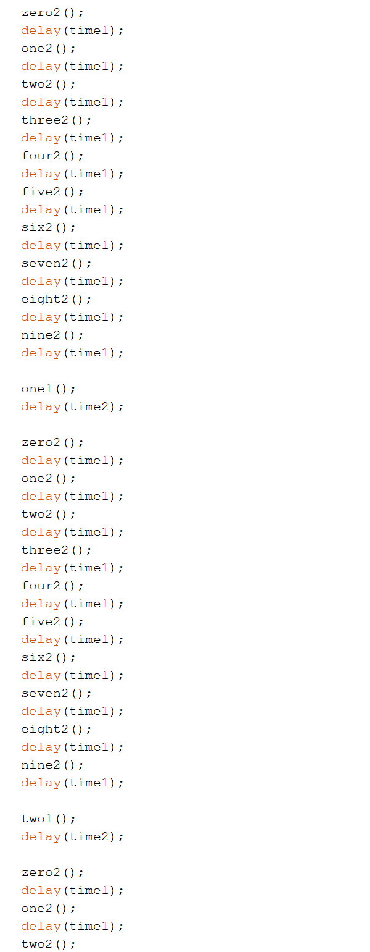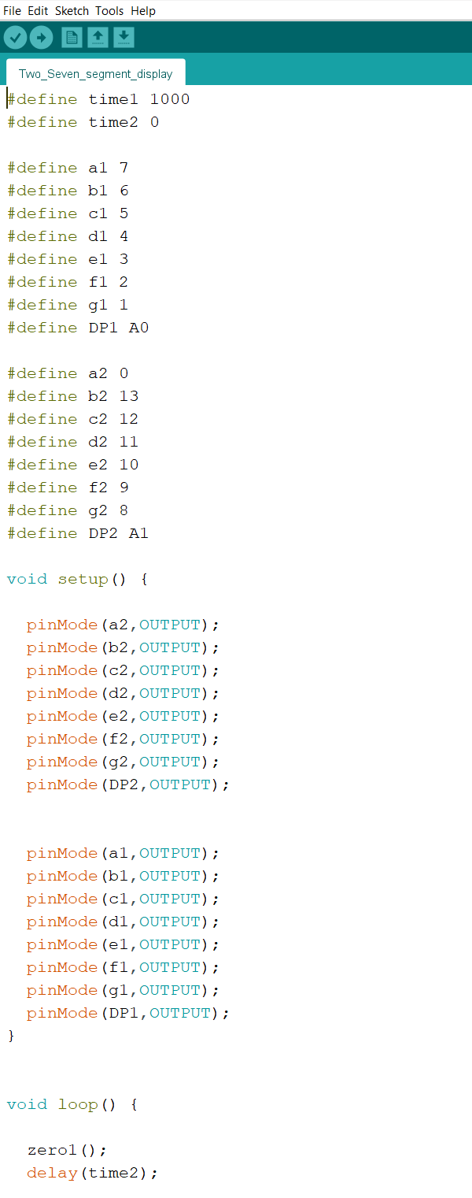

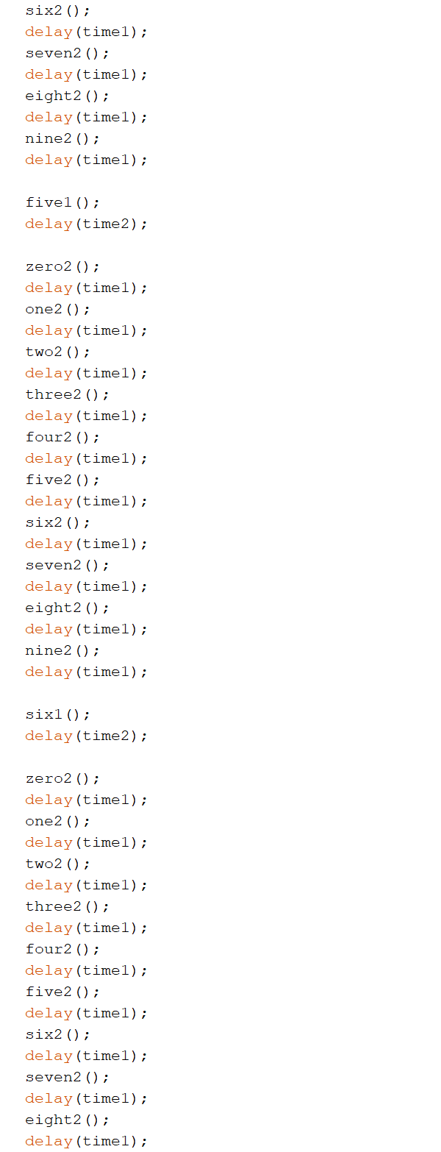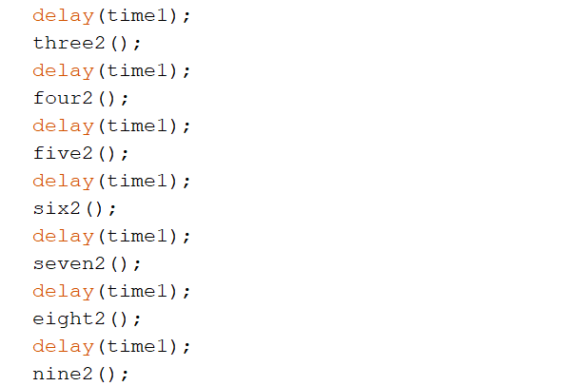

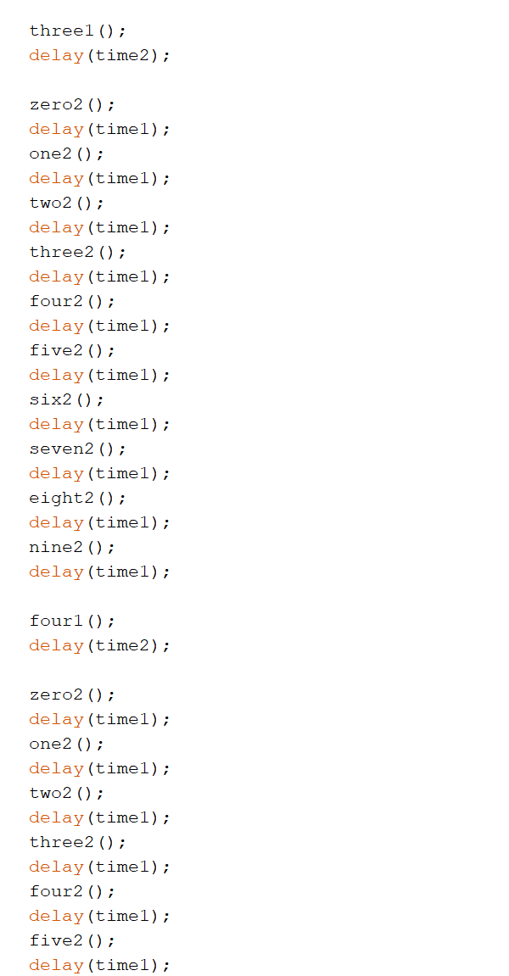

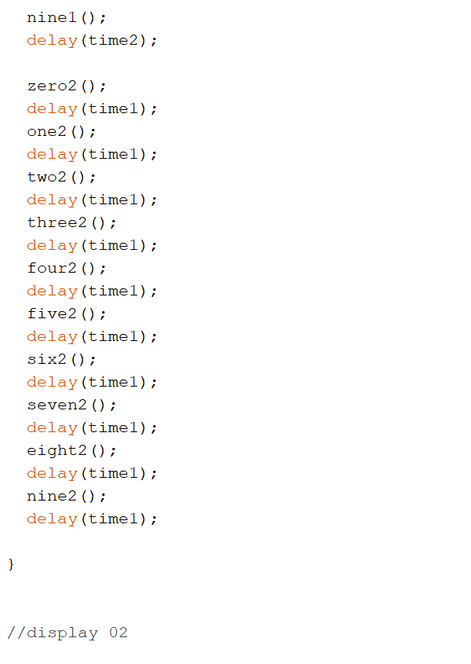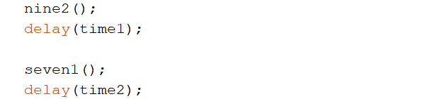

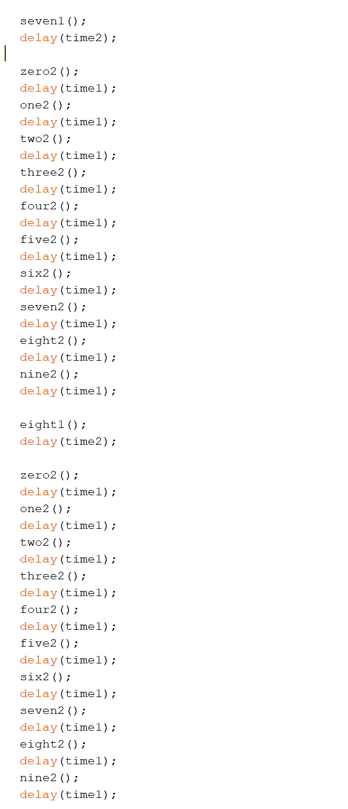



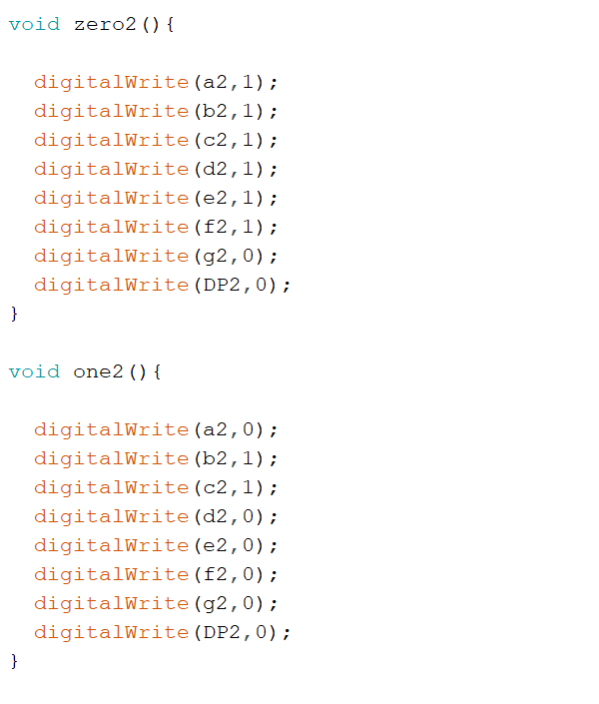

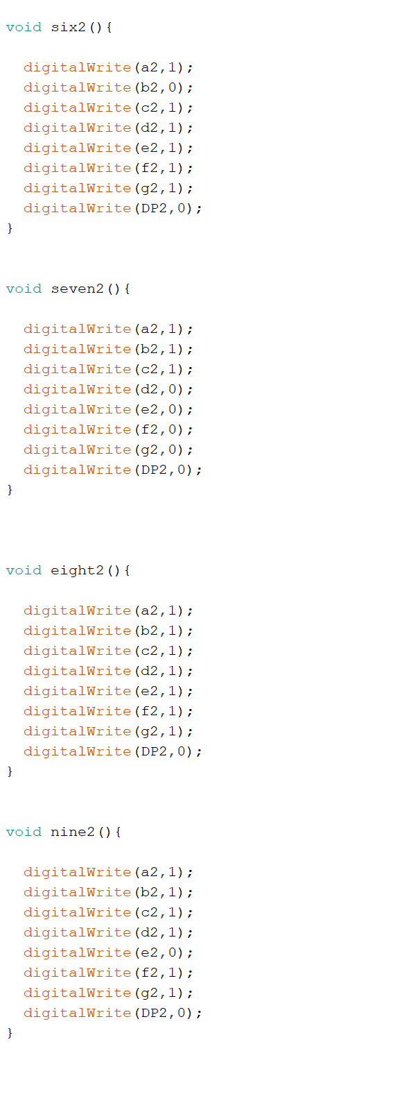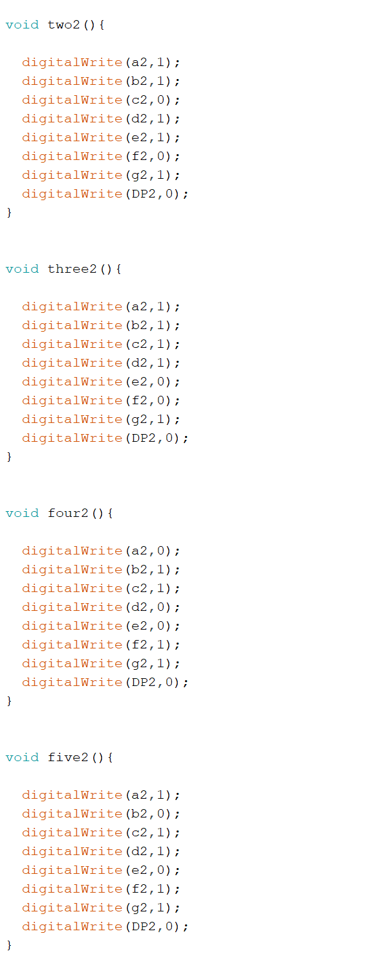

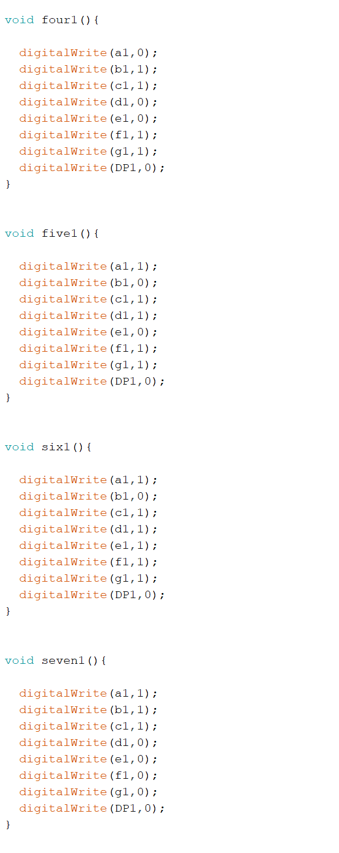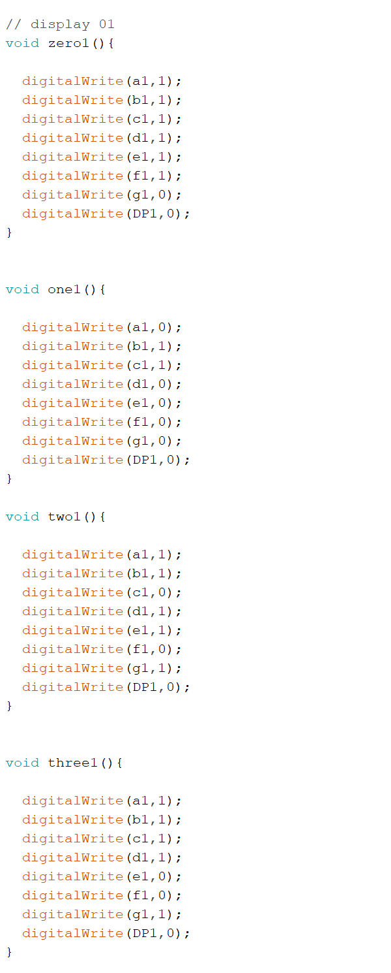

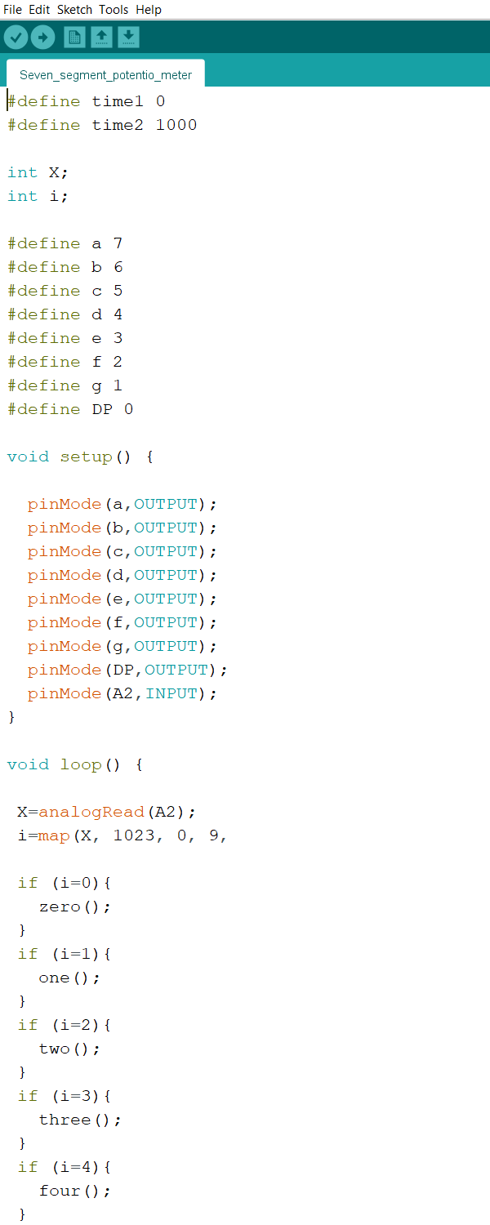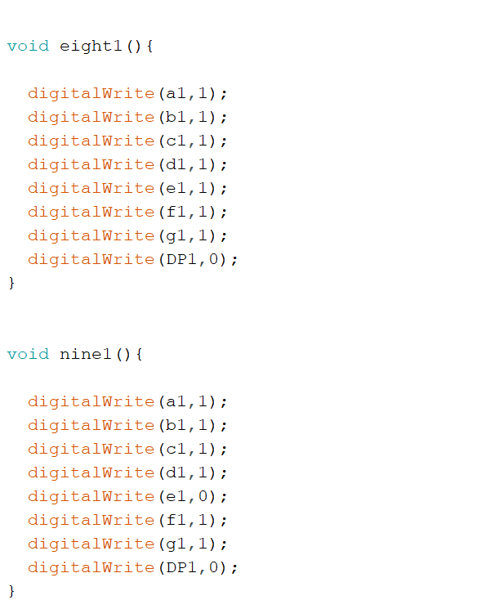



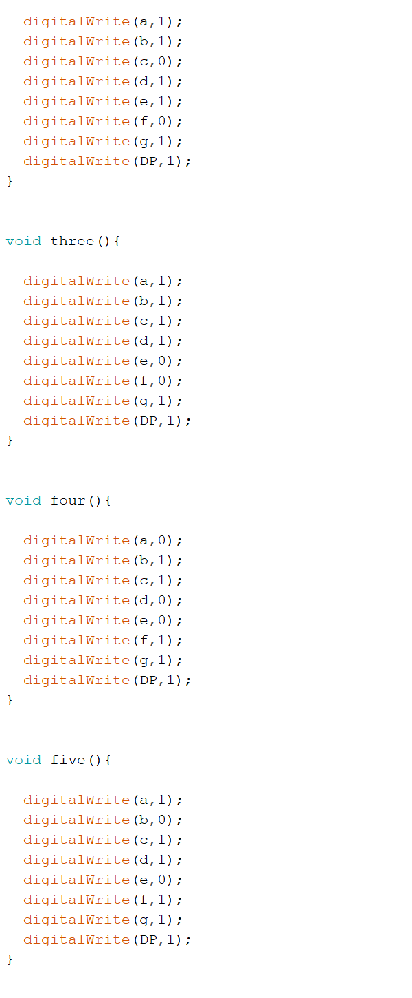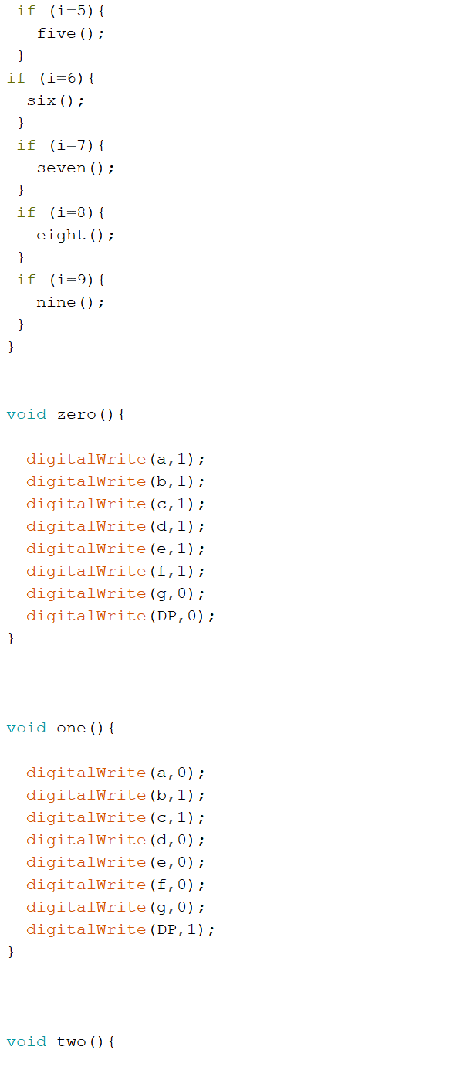

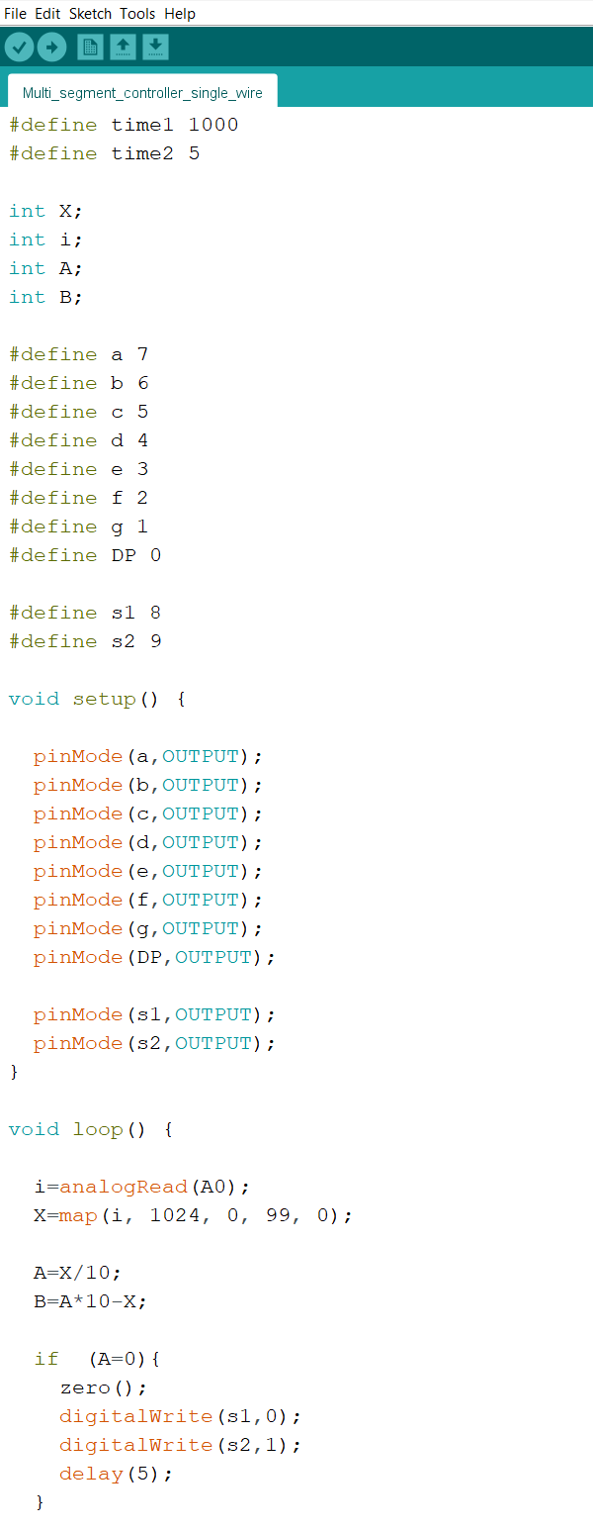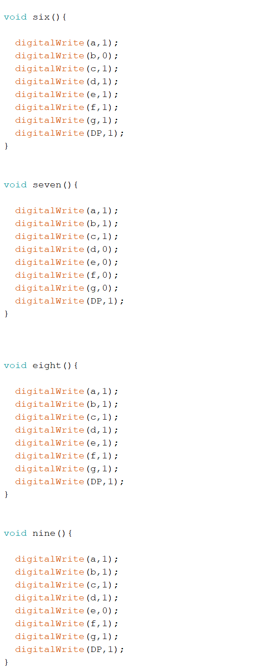



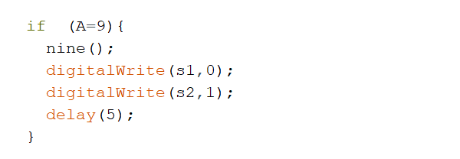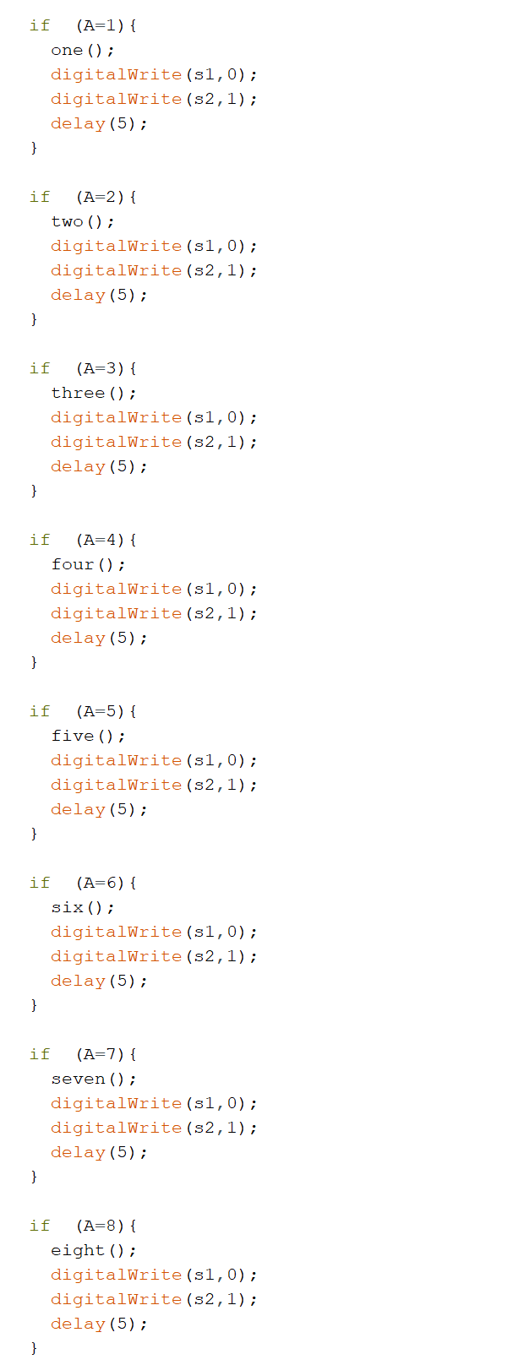

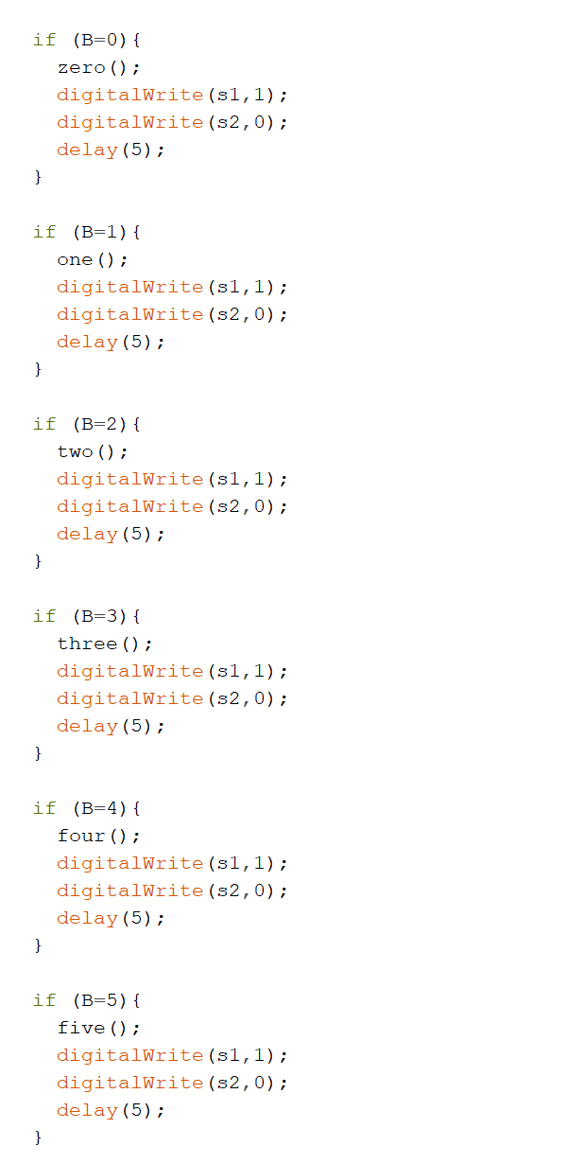

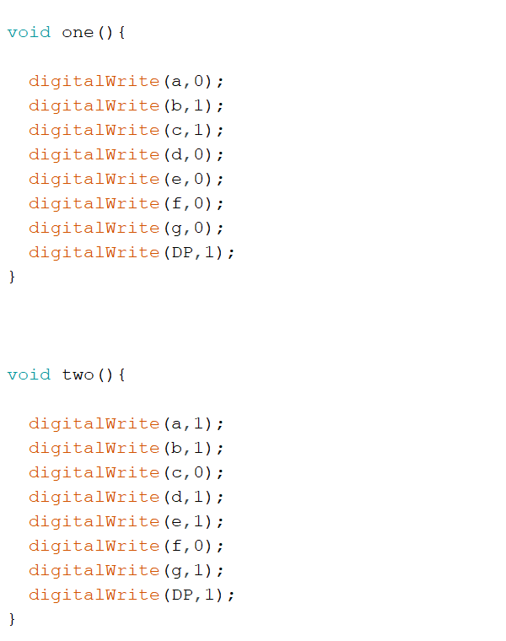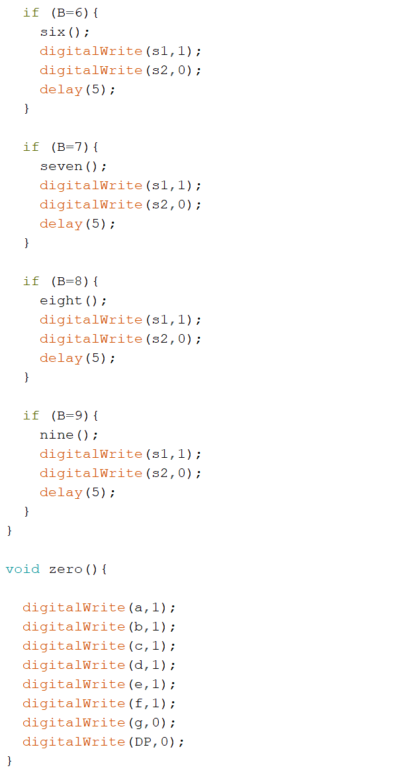

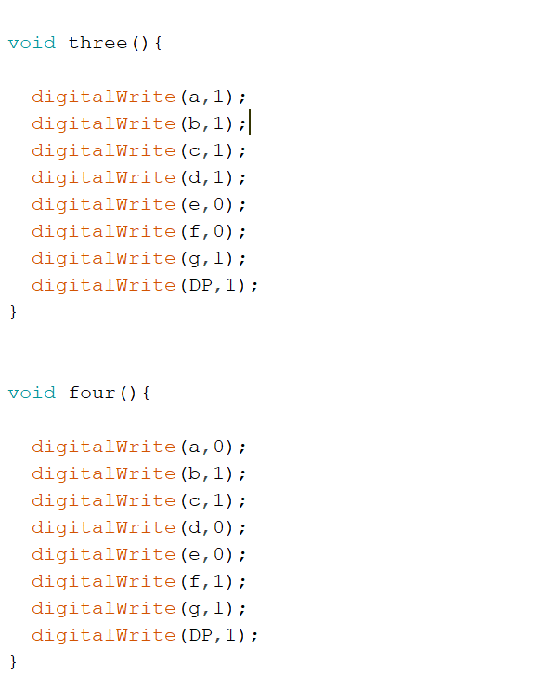

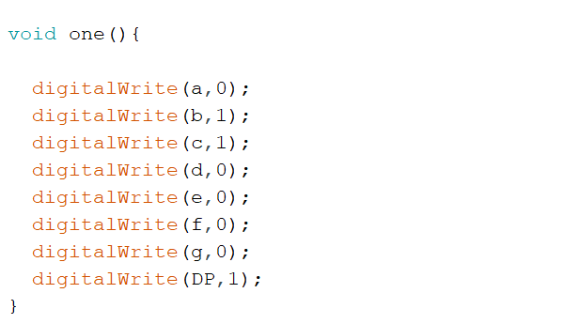

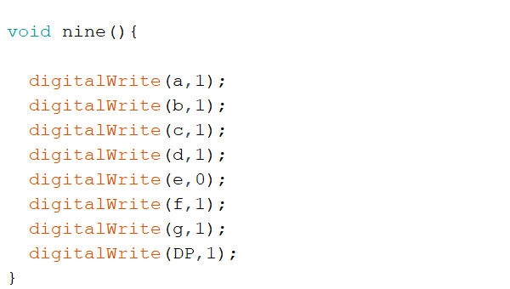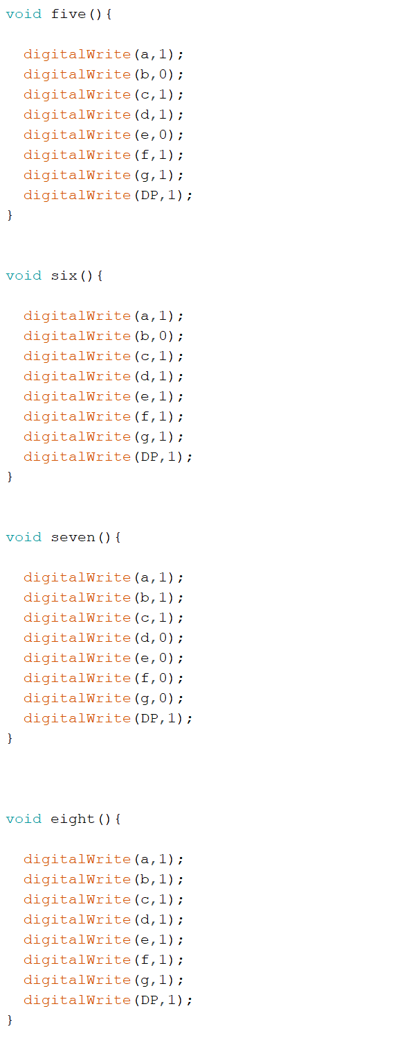



**Joystick Module**

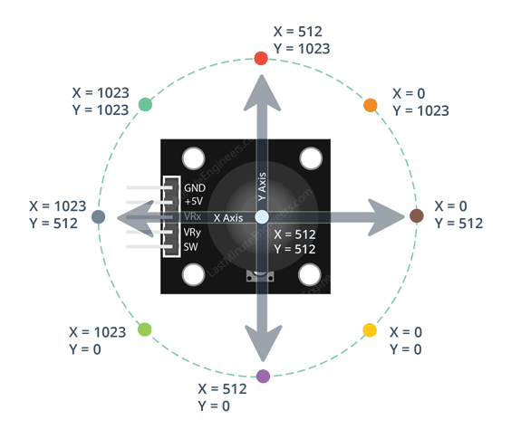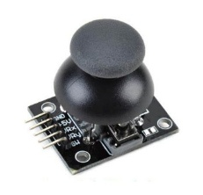

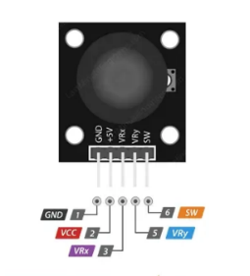

* Joystick module typically has 5 pins. The pinout for a Dual Axis XY Joystick Module typically

includes five pins, arranged in a row or a column.

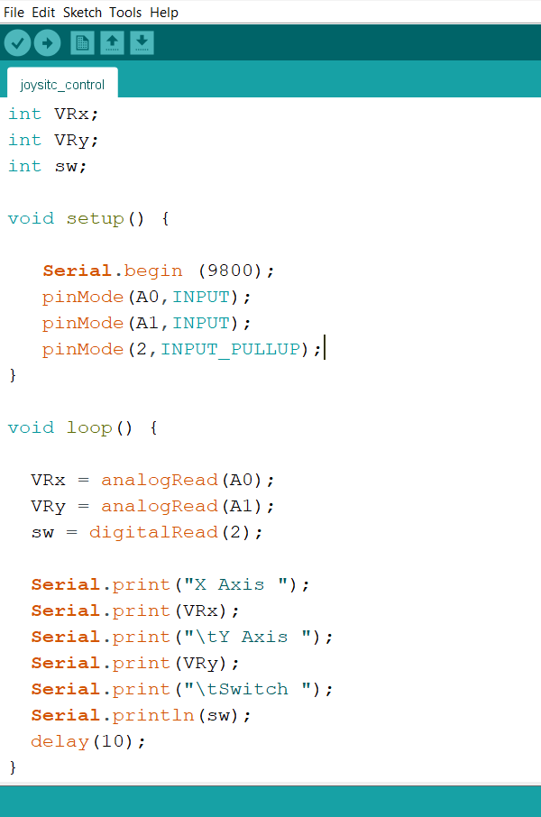

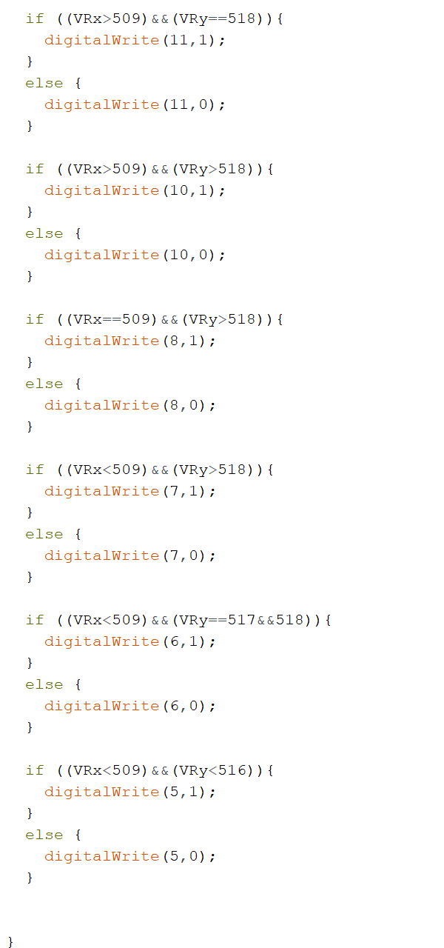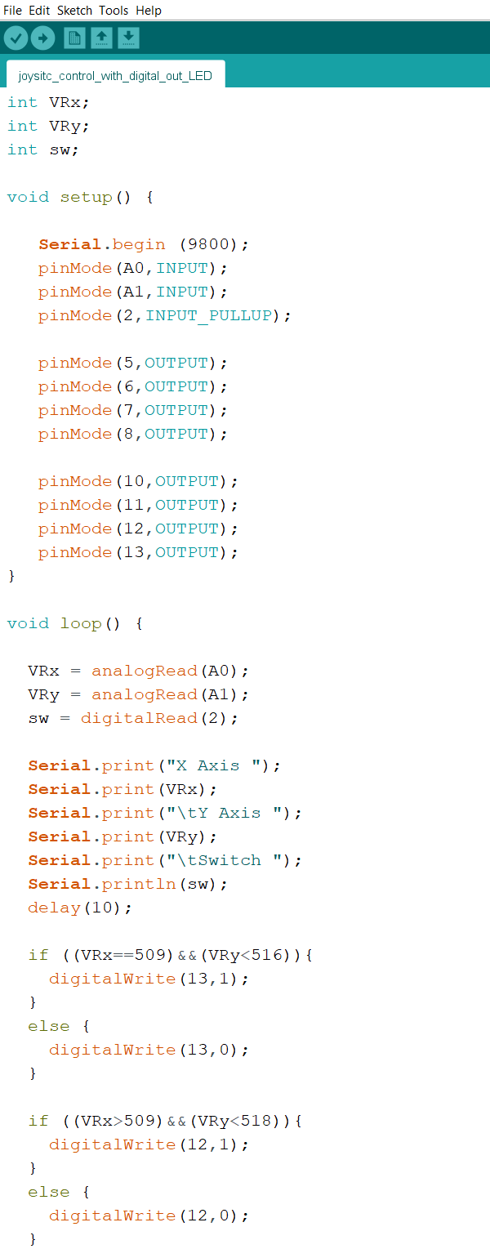



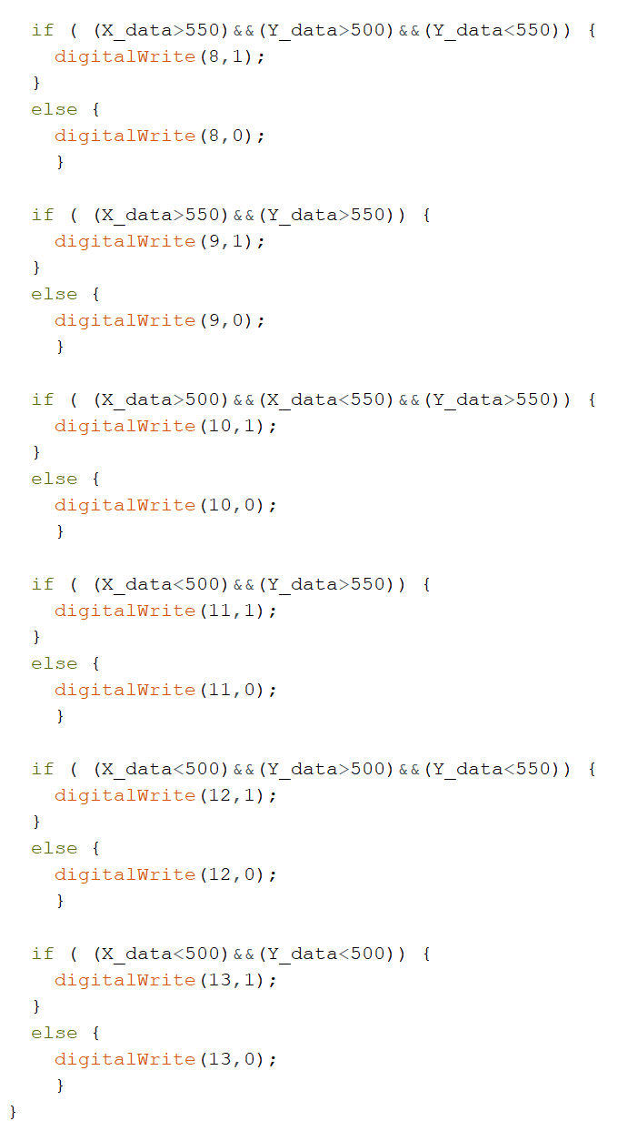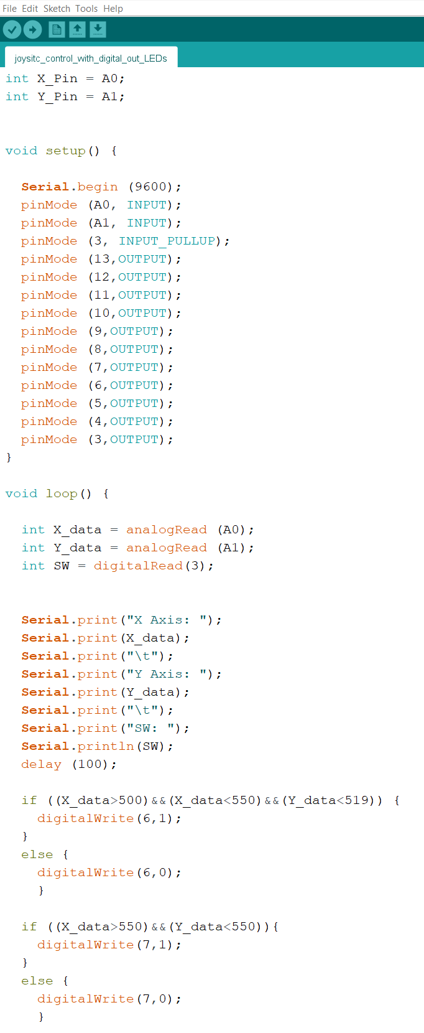



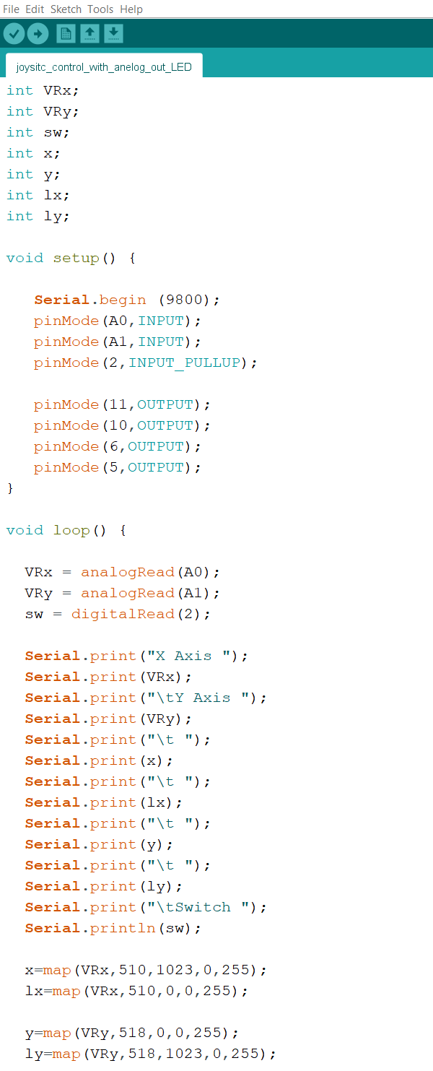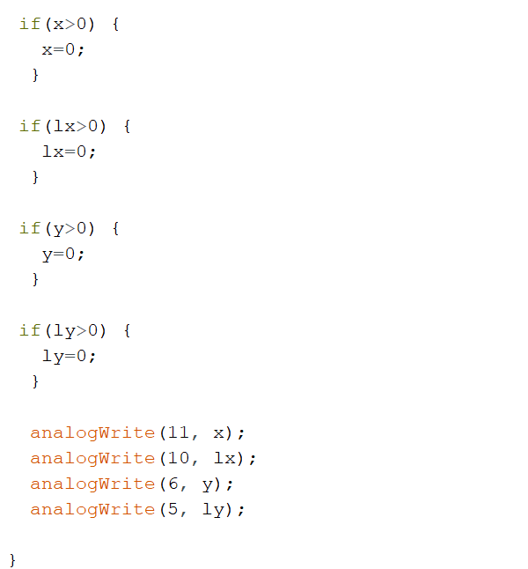



**Pulse Width Modulation (PWM)**

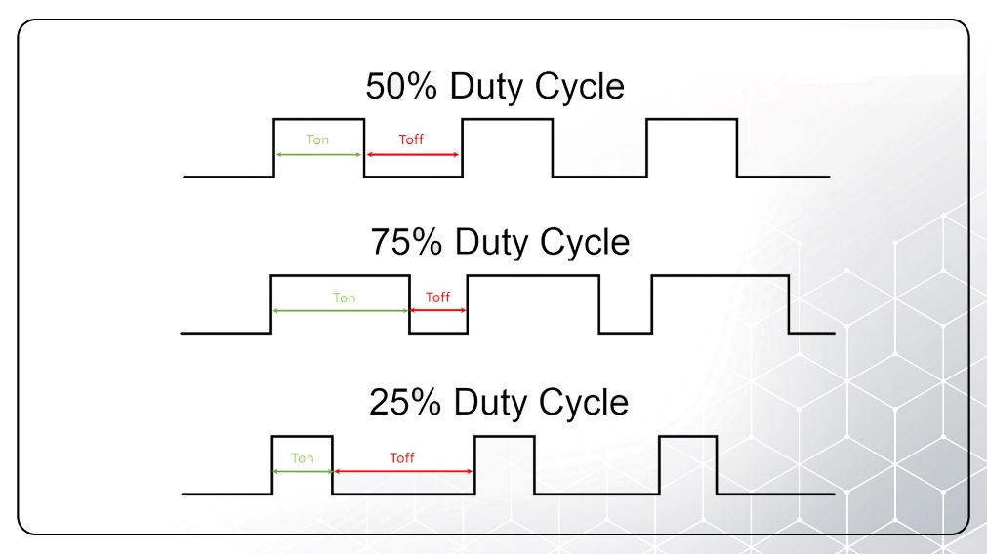

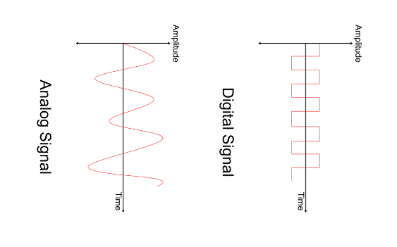

* Pulse Width Modulation (PWM) is a technique used to control the amount of power

delivered to an electrical load by varying the width of the pulses in a pulse train.

PWM is widely used in various applications, including motor control, audio amplification,

and power regulation.

**Motor Driver L298N**

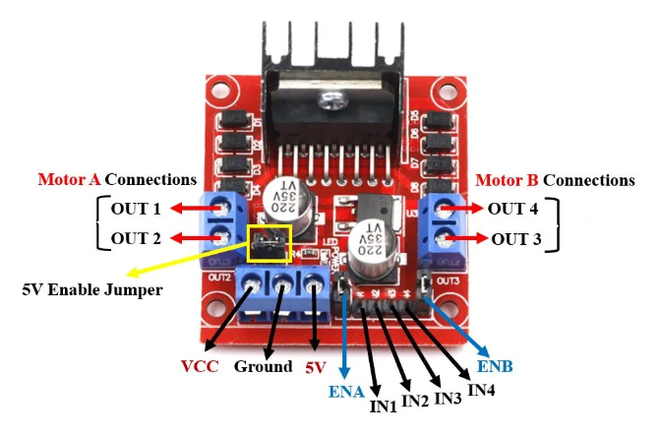

* The L293D is a motor driver IC designed to control the speed and direction of DC motors

and stepper motors. It operates on the H-bridge principle, which allows the motor to

rotate in both clockwise and counterclockwise directions by changing the polarity of the

voltage applied to it

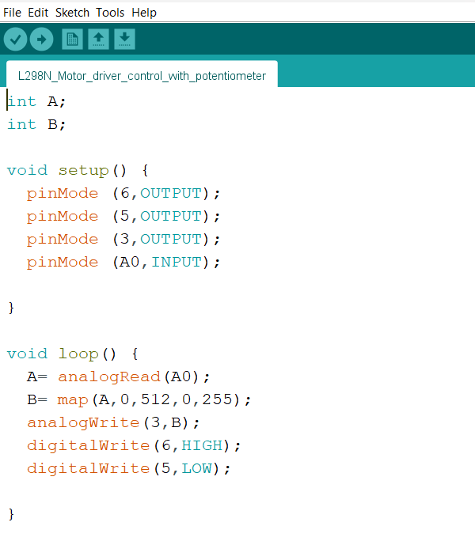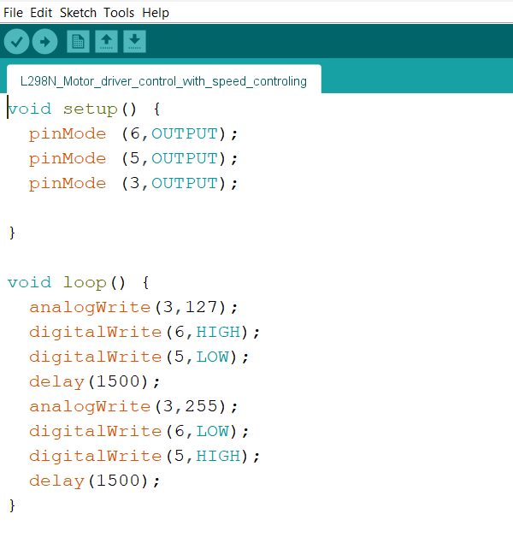





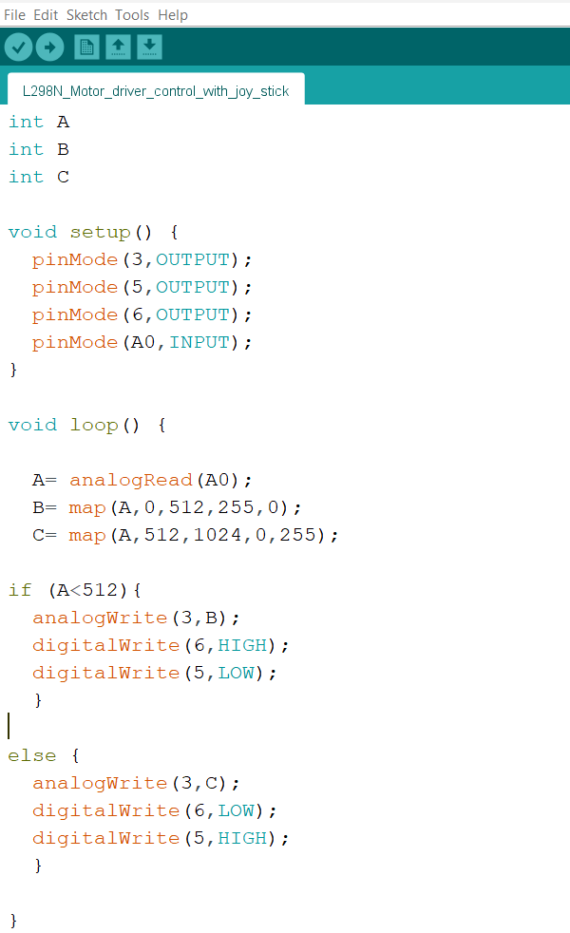



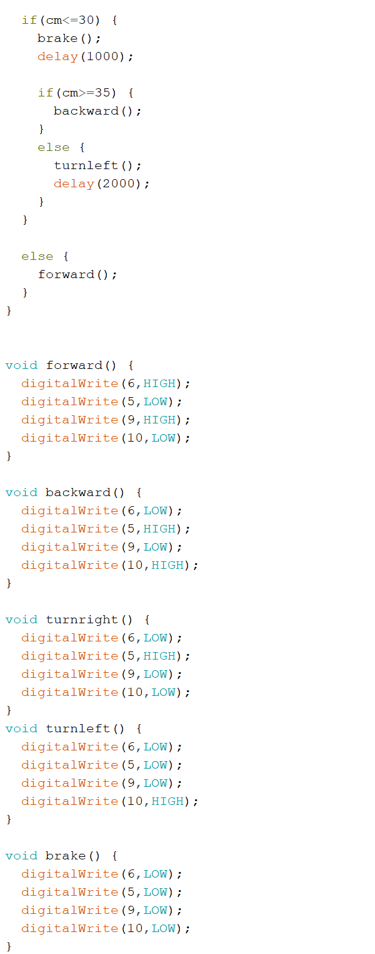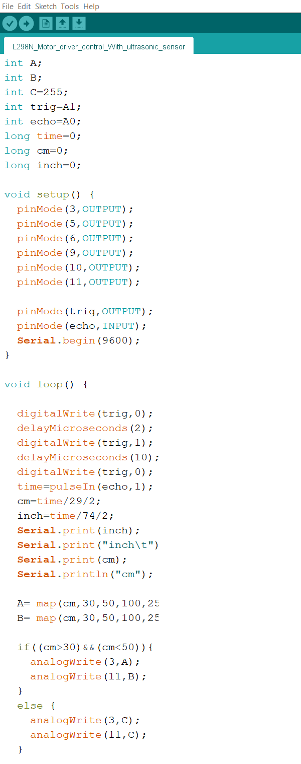



**Data Types**

**byte**

* A byte stores an 8-bit unsigned number, from 0 to 255.

|  |  |  |  |  |  |  |  |
| --- | --- | --- | --- | --- | --- | --- | --- |
| 0 | 1 | 2 | 3 | 4 | 5 | 6 | 7 |

bit

**int**

* Integers are your primary data-type for number storage.
* On the Arduino UNO (and other ATmega based boards) an int stores a 16-bit (2-byte)

value. This yields a range of -32,768 to 32,767 (minimum value of -2^15 and a maximum

value of (2^15) - 1).

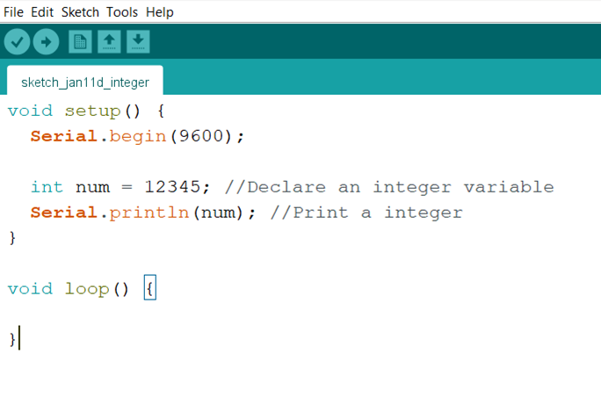



**long**

* Long variables are extended size variables for number storage, and store 32 bits

(4 bytes), from -2,147,483,648 to 2,147,483,647.

* If doing math with integers at least one of the values must be of type long.

**float**

* Datatype for floating-point numbers, a number that has a decimal point. Floating-point

numbers are often used to approximate analog and continuous values because they

have greater resolution than integers. Floating-point numbers can be as large as

3.4028235E+38 and as low as -3.4028235E+38. They are stored as 32 bits (4 bytes) of

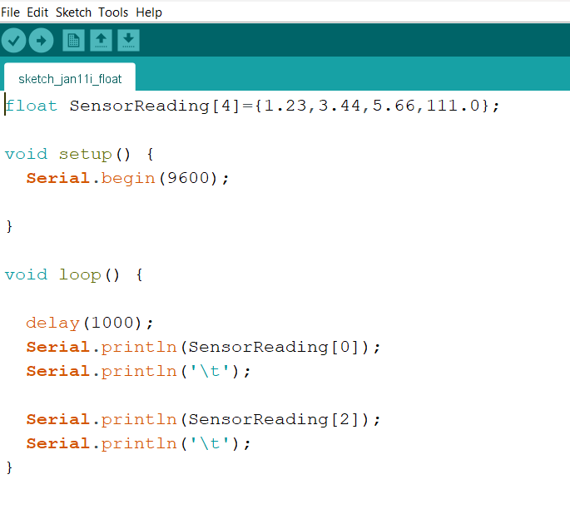 information.



**bool**

* A bool holds one of two values, true or false. (Each bool variable occupies one byte of

memory.)

**double**

* Double precision floating point number. On the UNO and other ATMEGA based boards,

this occupies 4 bytes. That is, the double implementation is exactly the same as the float,

with no gain in precision.

* On the Arduino Due, doubles have 8-byte (64 bit) precision.

**char**

* A data type used to store a character value. Character literals are written in single quotes,

like this: A (for multiple characters - strings - use double quotes: "ABC").

* The size of the char datatype is at least 8 bits. It’s recommended to only use char for

storing characters. For an unsigned, one-byte (8 bit) data type, use the byte data type.

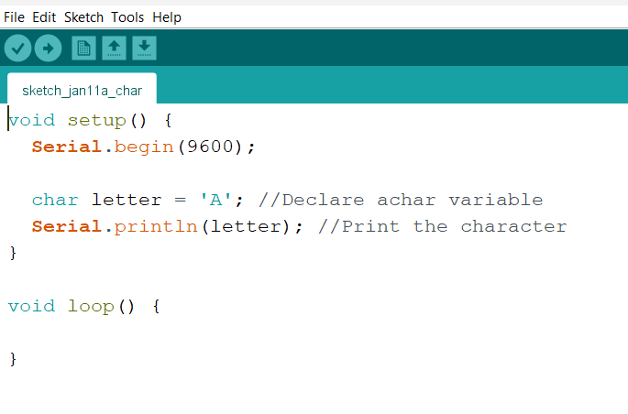



* stores a single character or a small number (1 byte )

Rangge :- 128 to 127 ( ASCII value )

**string**

* Text strings can be represented in two ways. you can use the String data type, or you can

make a string out of an array of type char and null-terminate it. This page describes the

latter method. For more details on the String object, which gives you more functionality

at the cost of more memory, see the String object page.

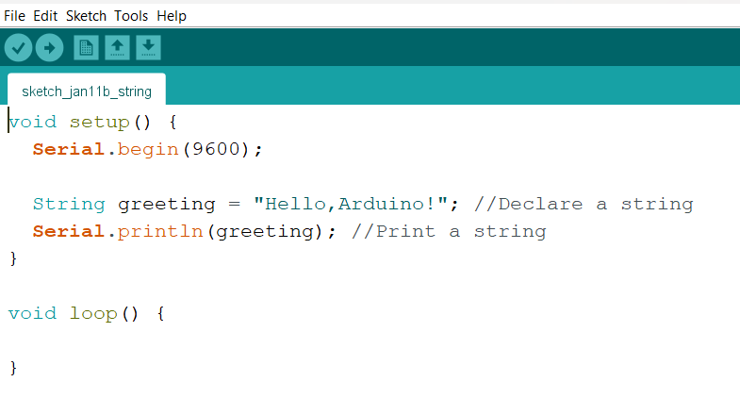



**array**

* An array is a collection of variables that are accessed with an index number. Arrays in the

C++ programming language Arduino sketches are written in can be complicated, but using

simple arrays is relatively straightforward.

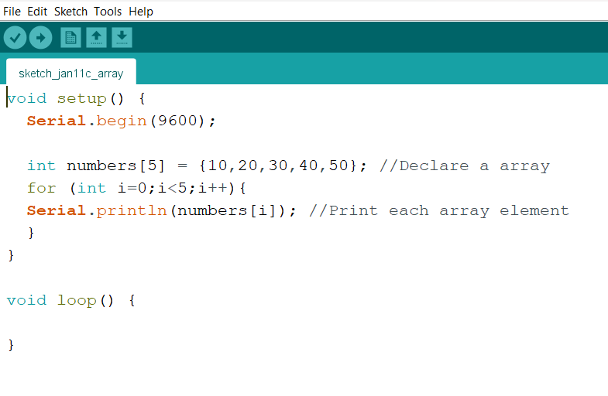



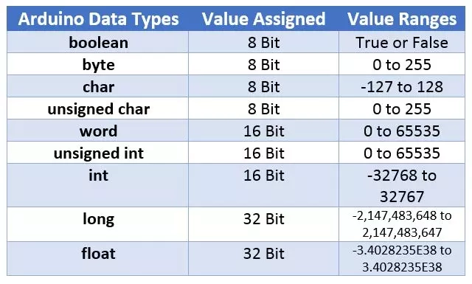

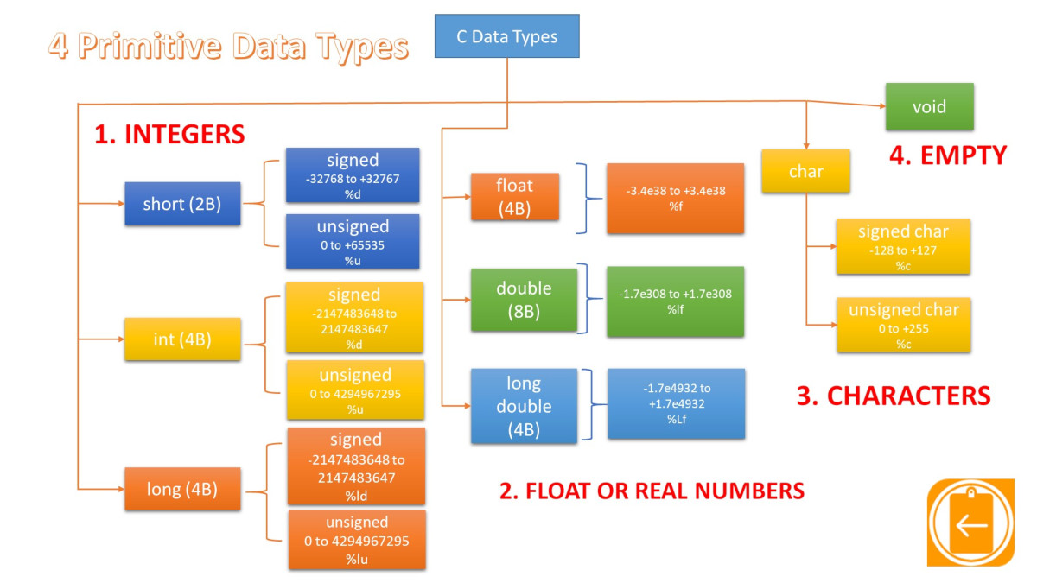

Addition Subtraction

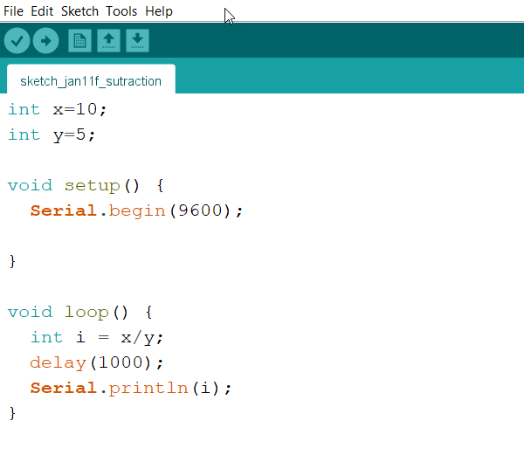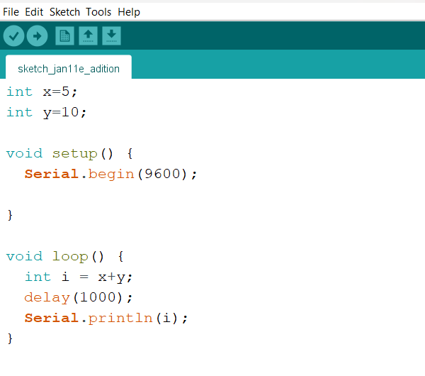



Multiplication Division

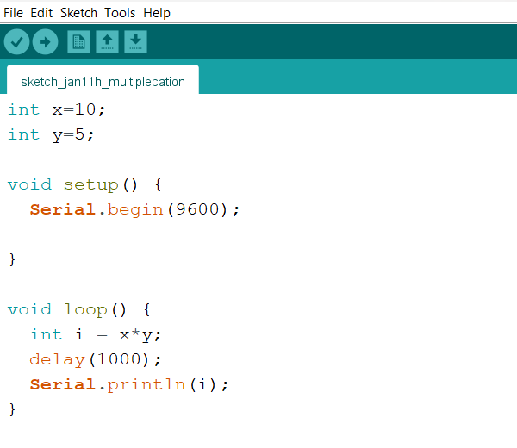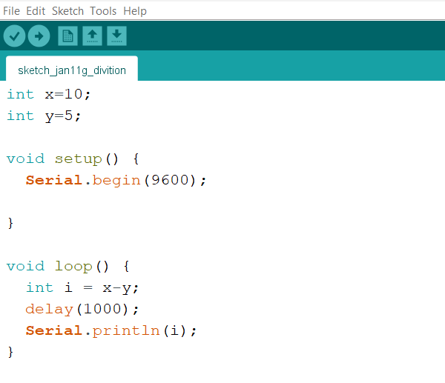



**Servo System**

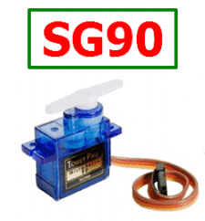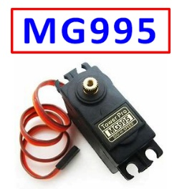

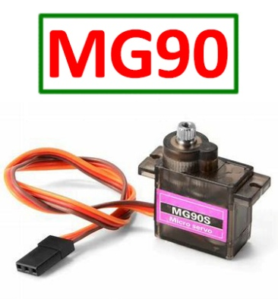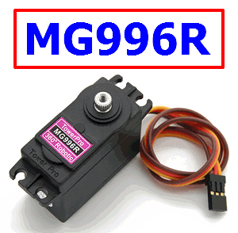

* A **servo** motor is a type of electric motor that can rotate or move to a specific position,

speed, or torque based on an input signal from a controller.

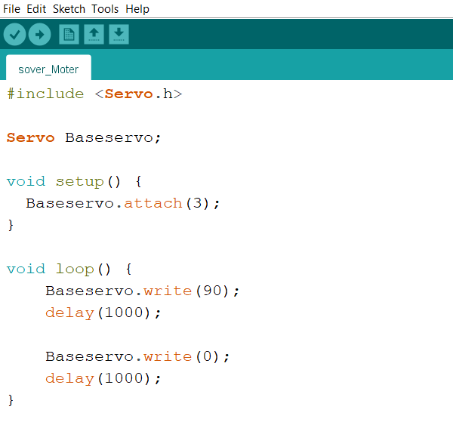



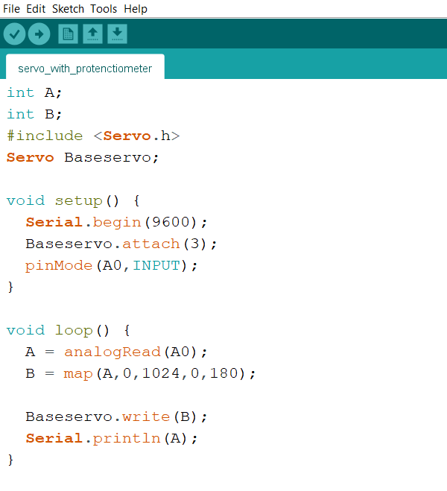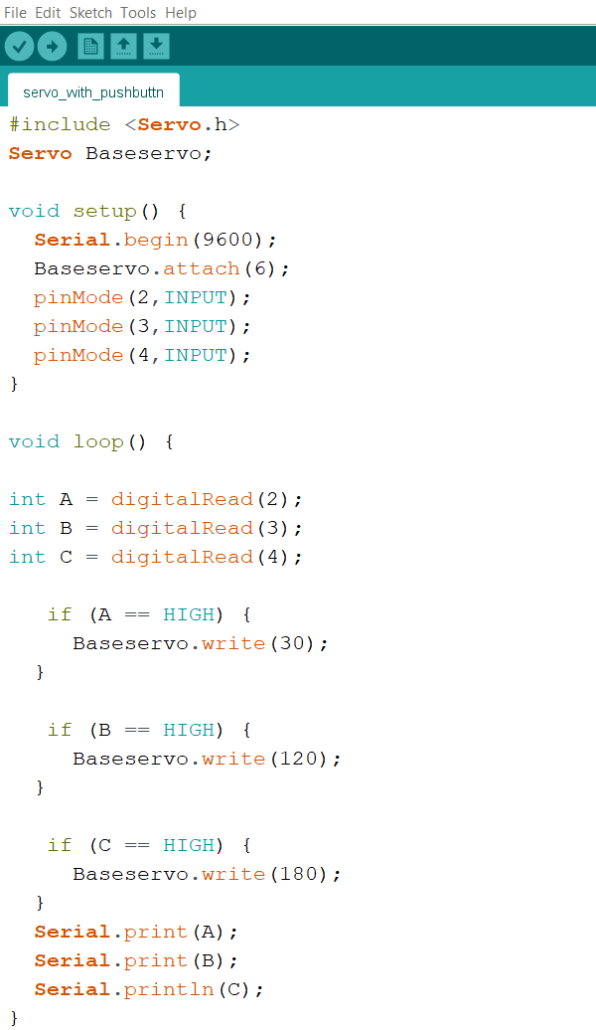





**Relay Module**

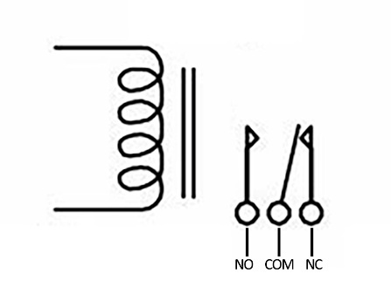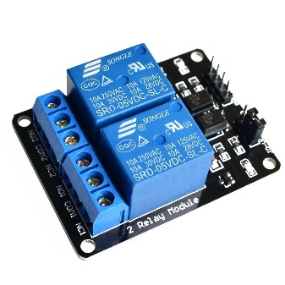

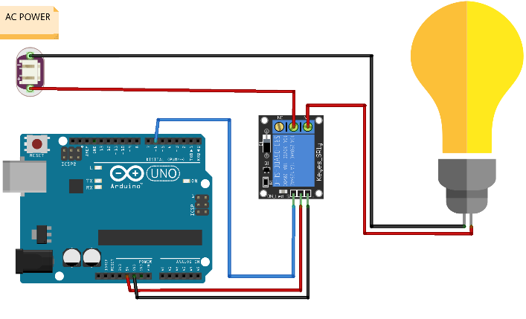

* relay module is a switching device that allows low-power circuits (such as digital electronics

or microcontrollers) to control high-powered devices (such as motors or lighting circuits).

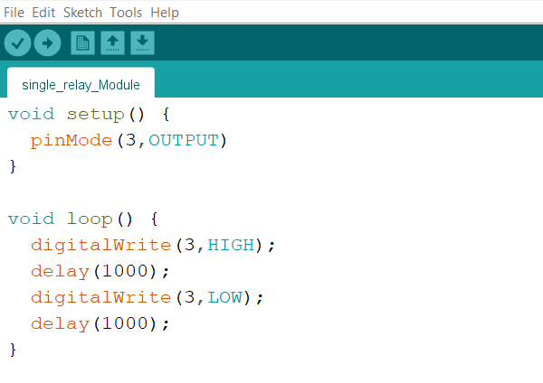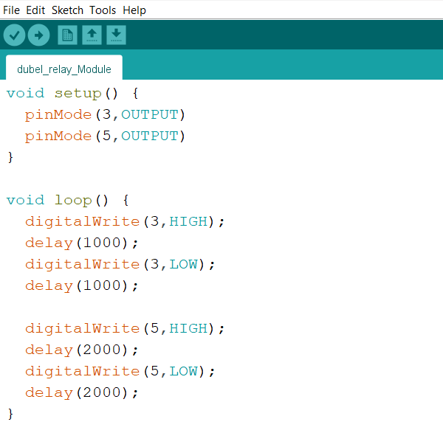





**LDR Sensor Module**

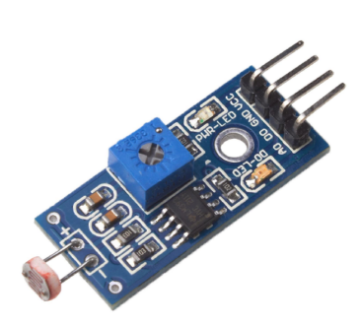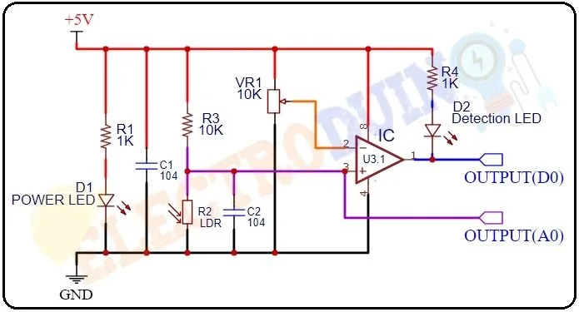

* LDR sensor module, also known as a Light Dependent Resistor or Photoresistor, is a device

that can detect the intensity of light in the environment. It has a variable resistance that

changes with the light intensity.

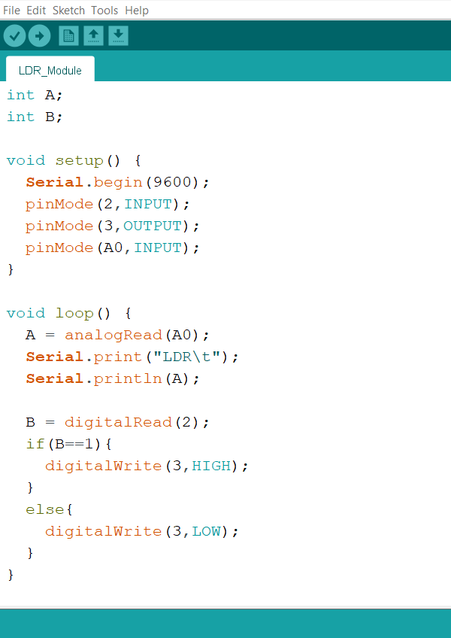

**IR Sensor Module**

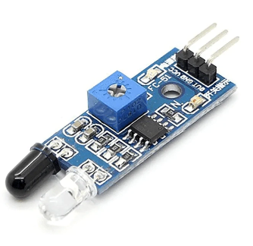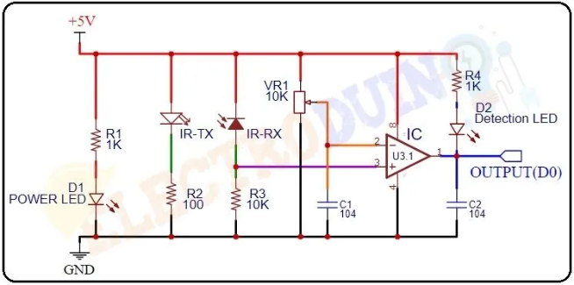

* IR Sensor Module consists of an IR transmitter and receiver circuit. The IR transmitter emits

infrared light, which is detected by the IR receiver. The module also includes an infrared

detector, an amplifier, and a signal processing circuit.

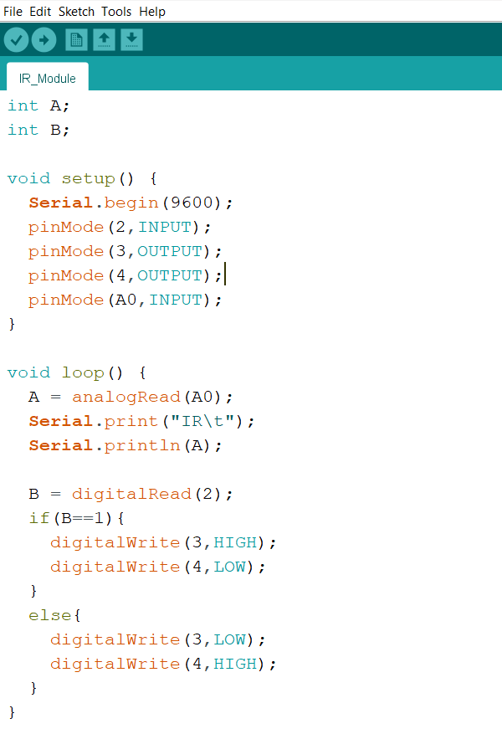



**Keypad Module**

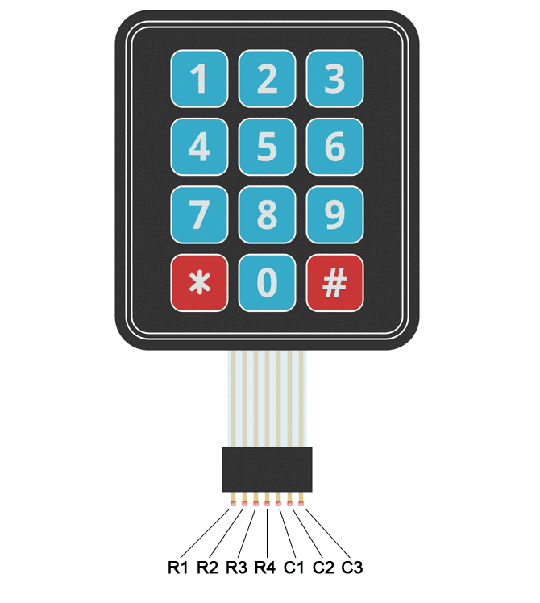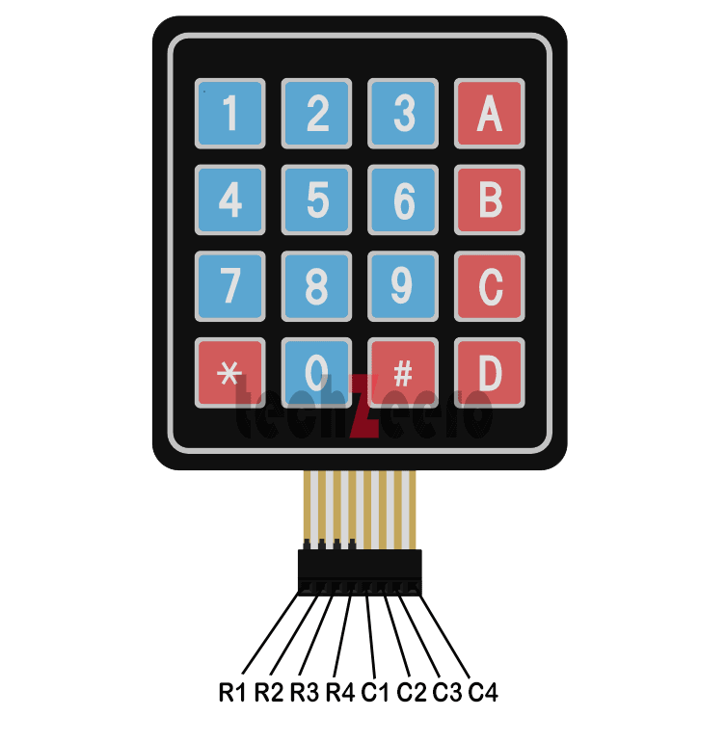

* Keypad module is an input device commonly used in interface for entering data or

commands. These modules come in various configurations, such as 4x3 (12 keys) or

4x4 (16 keys).

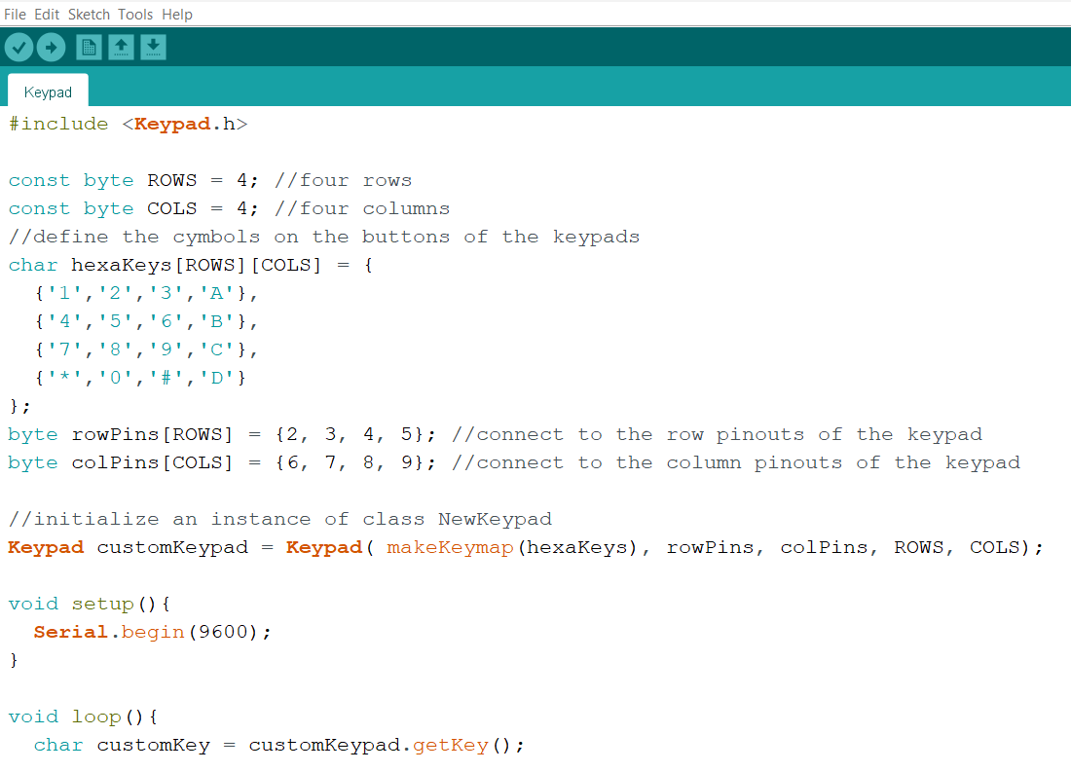

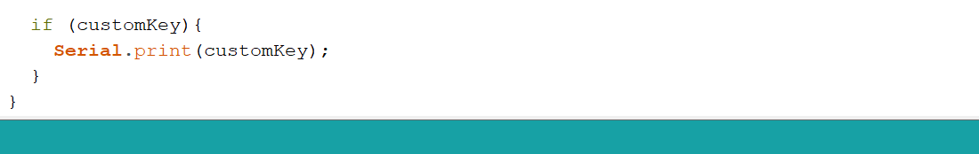

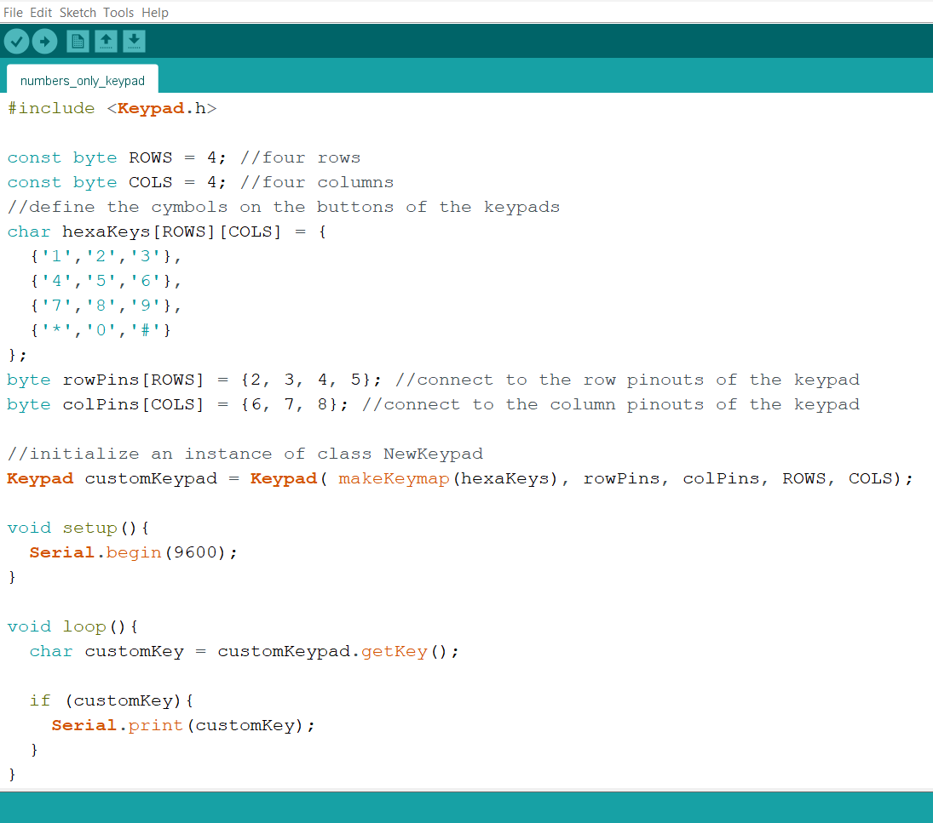

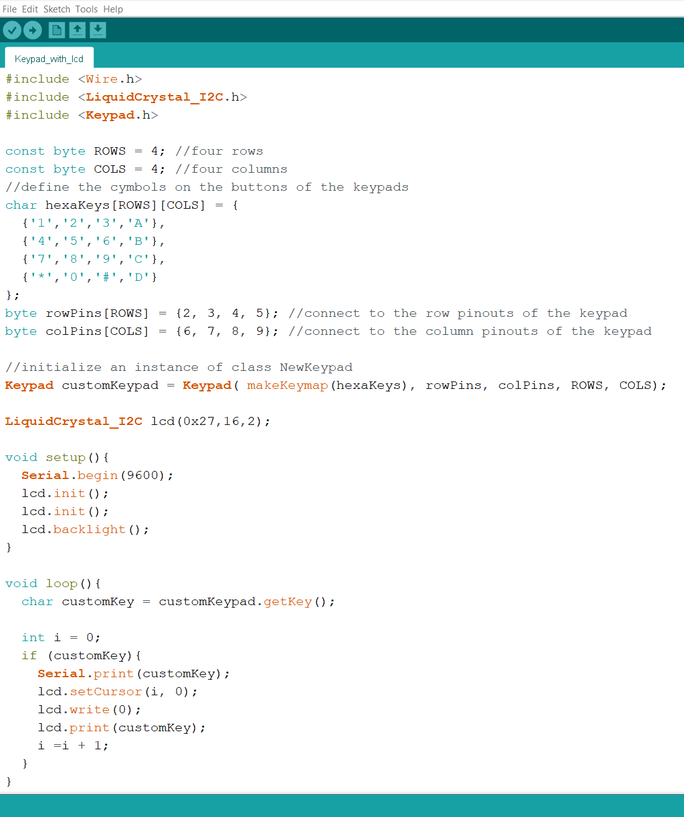

**Arduino Software Serial**

* Arduino Software Serial library allows users to create additional serial communication ports

on the Arduino board using software. This is especially used when more serial ports

needed than the hardware provides. With Software Serial any digital pins can be defined as

RX (receive) and TX (transmit) pins for communication.

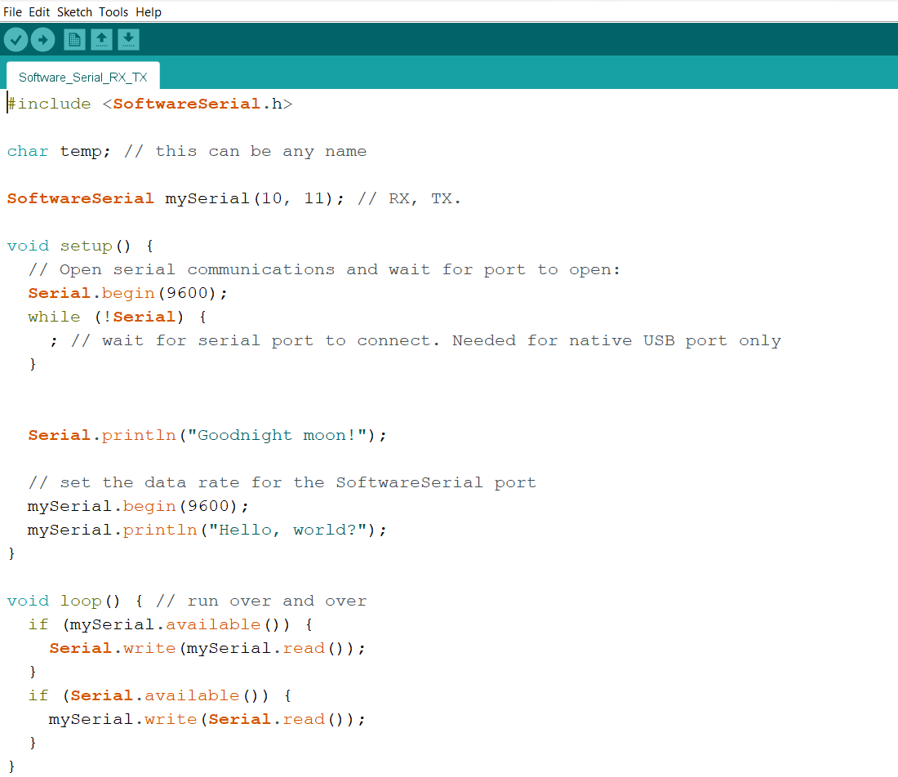



**Bluetooth Module**

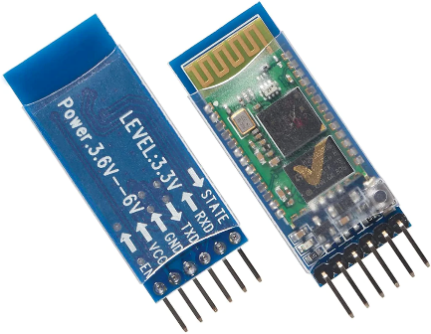

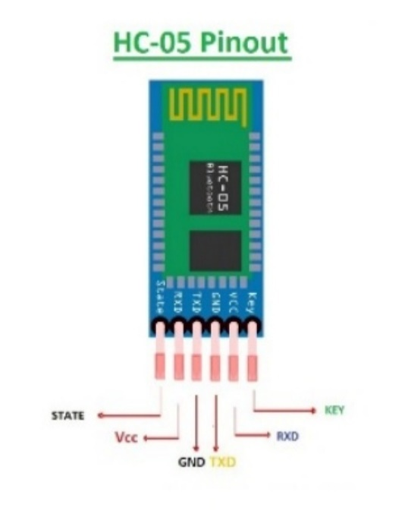

* Bluetooth module is a specialized chip that wirelessly connects two compatible devices for

communication using low energy waves. These modules act as the interface between the

microcontroller and the devices.

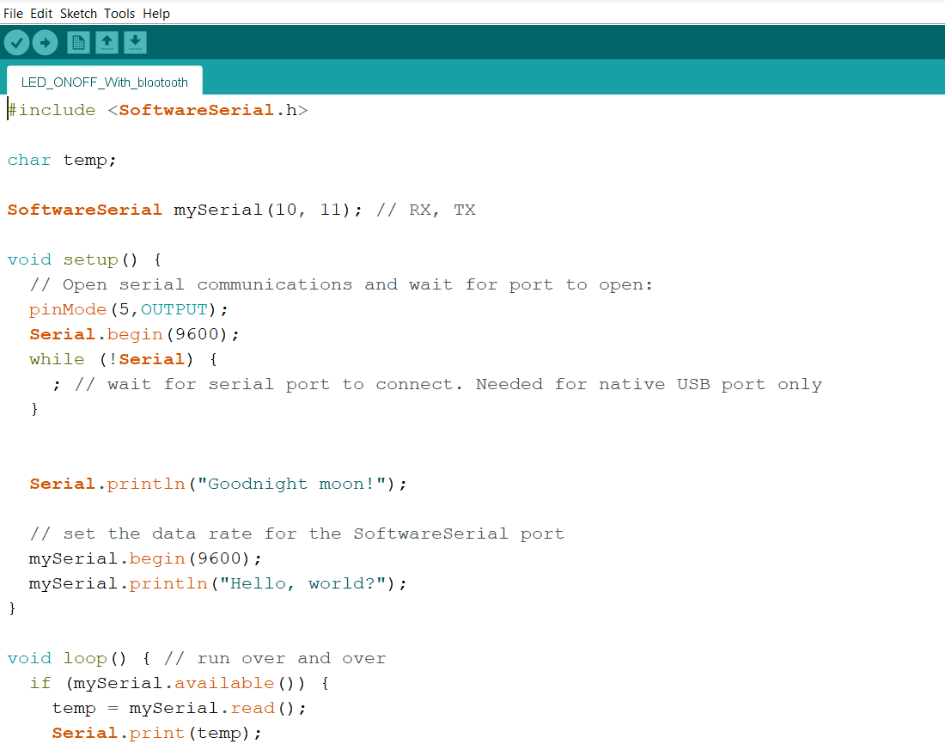

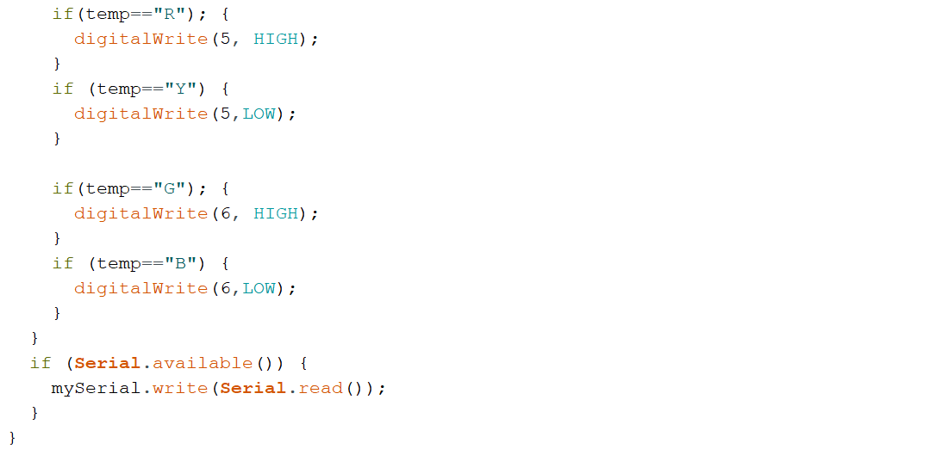



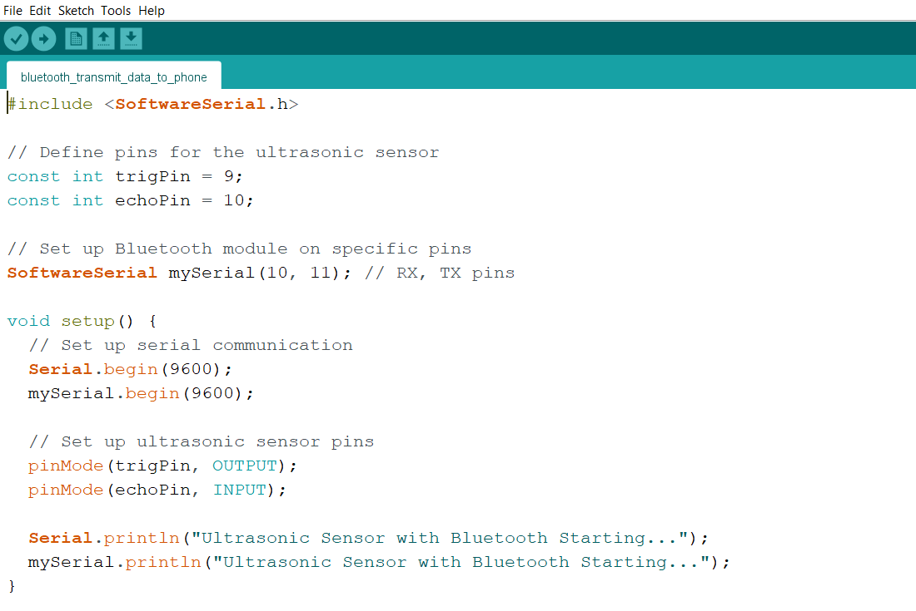

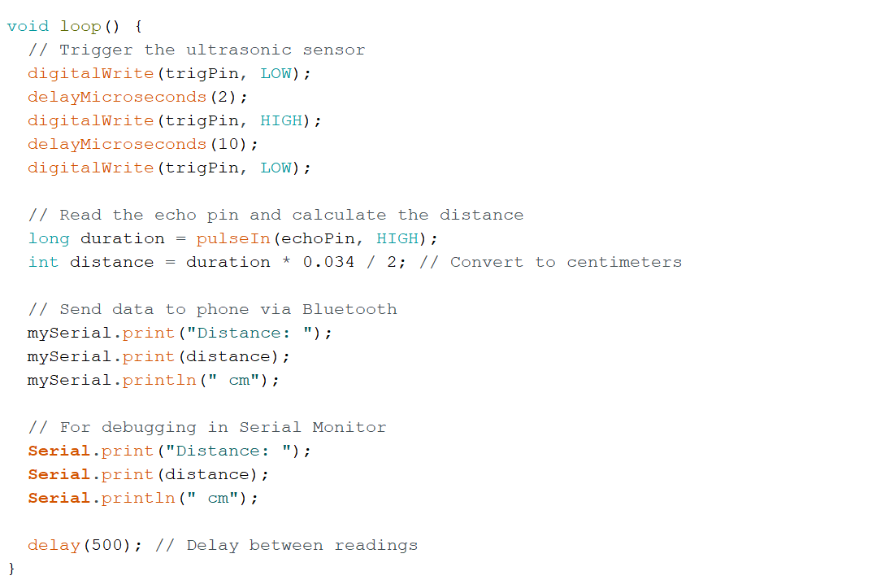



**Stepper Motor**

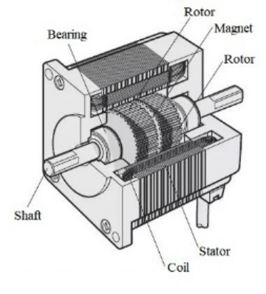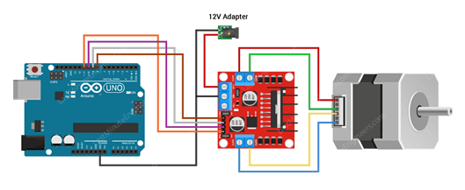

* stepper motor is a brushless DC electric motor that rotates in a series of small and discrete

angular steps. Stepper motors can be set to any given step position without needing a

position sensor for feedback.

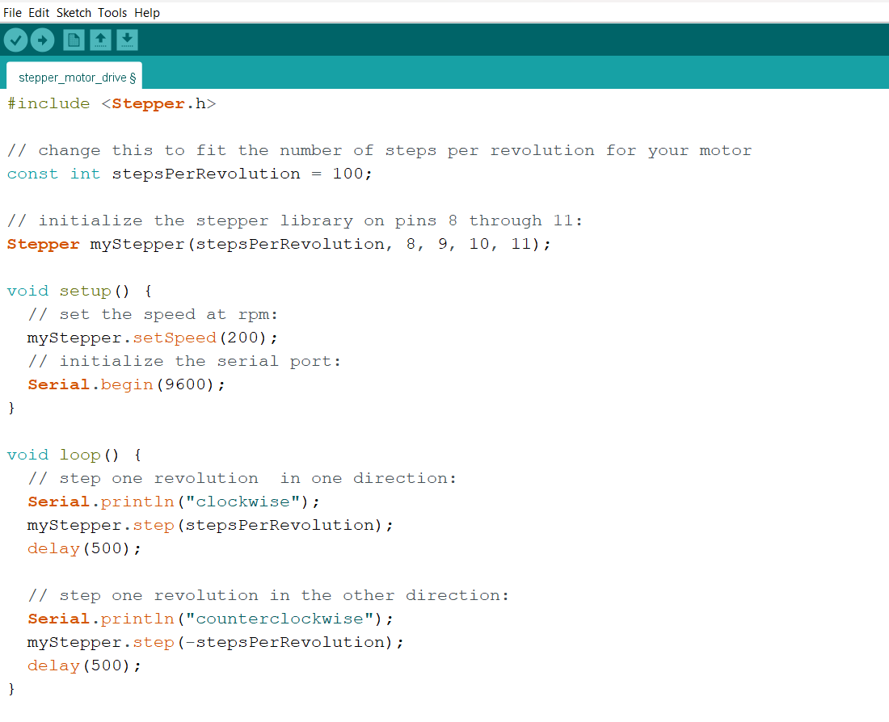



**Brushless DC Motor**

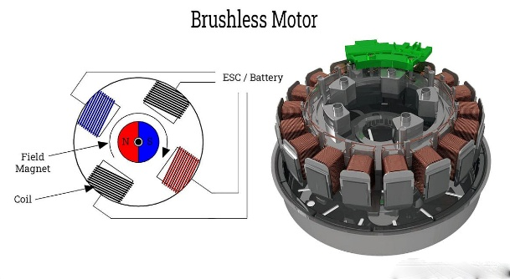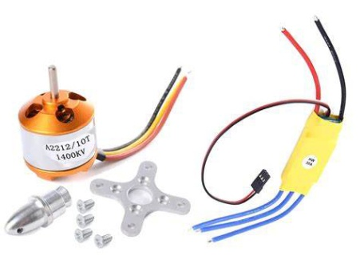

* Brushless DC Motor (BLDC) is an efficient, durable electric motor that operates without

brushes, relying on electronic commutation. It's widely used in drones, electric vehicles,

and appliances.

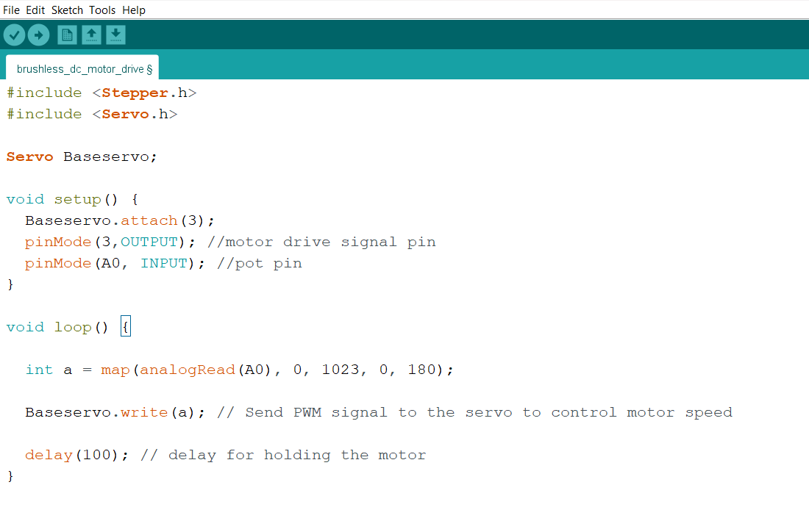



**Arduino Serial Communication**

* Serial communication links two Arduino boards via TX (transmit) and RX (receive) pins

with a shared GND. Use Serial.print() to send and Serial.read() to receive data.

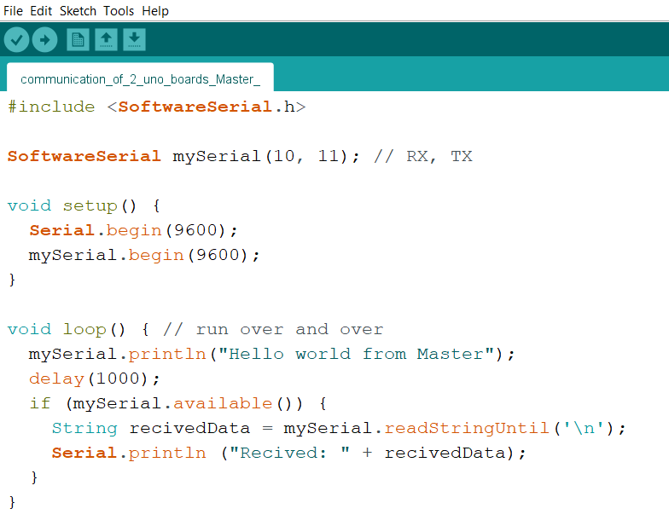



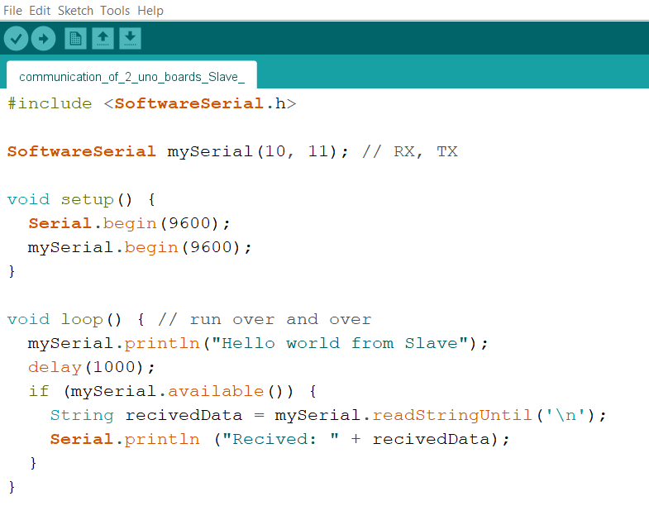



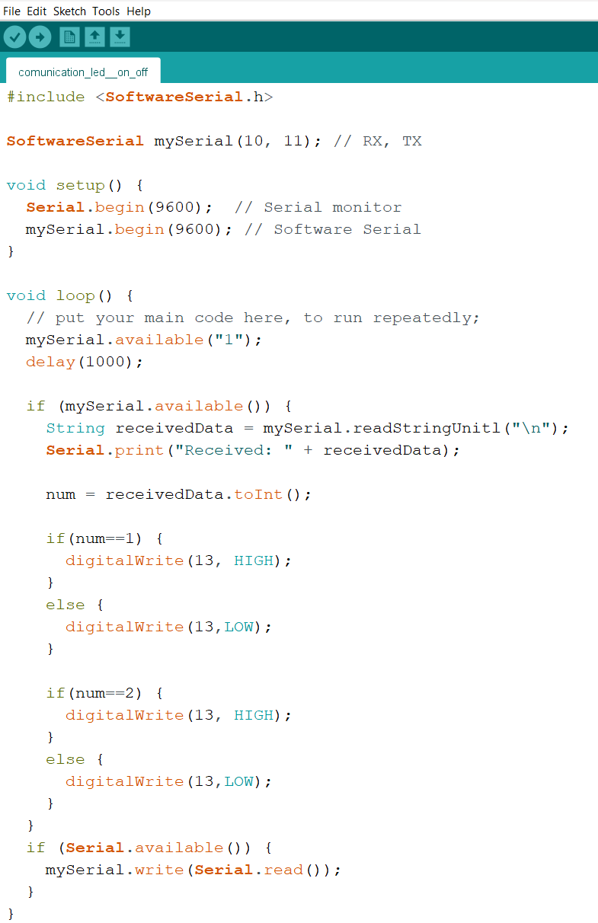



**Encoder Module**

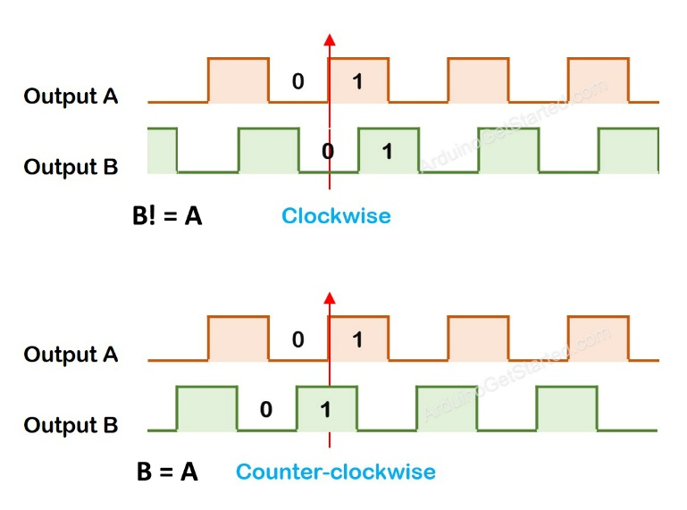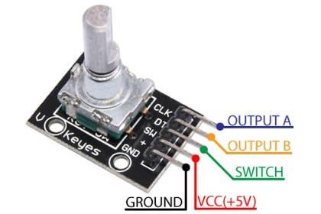

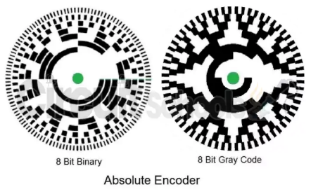

* Encoder modules constitute an integral part of various digital signal processing systems

and artificial intelligence models. These modules encode the input data into a format that

is easier for the system or model to interpret and process.

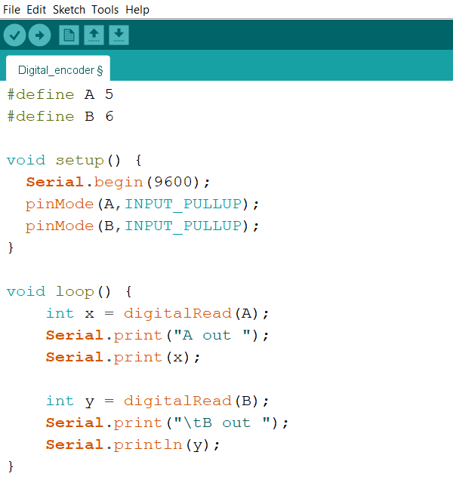



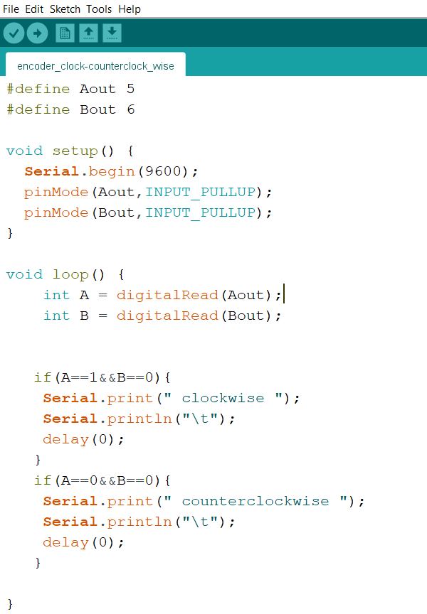



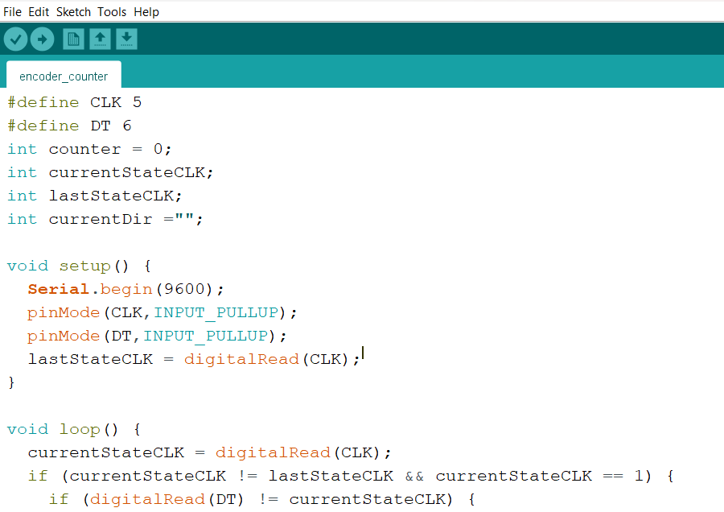

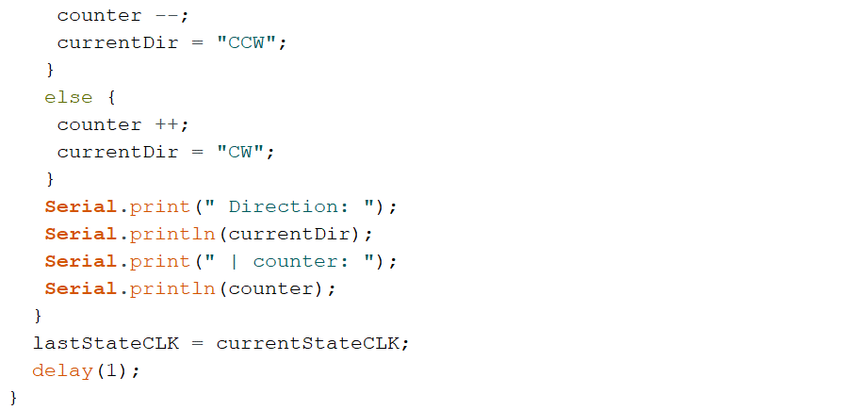



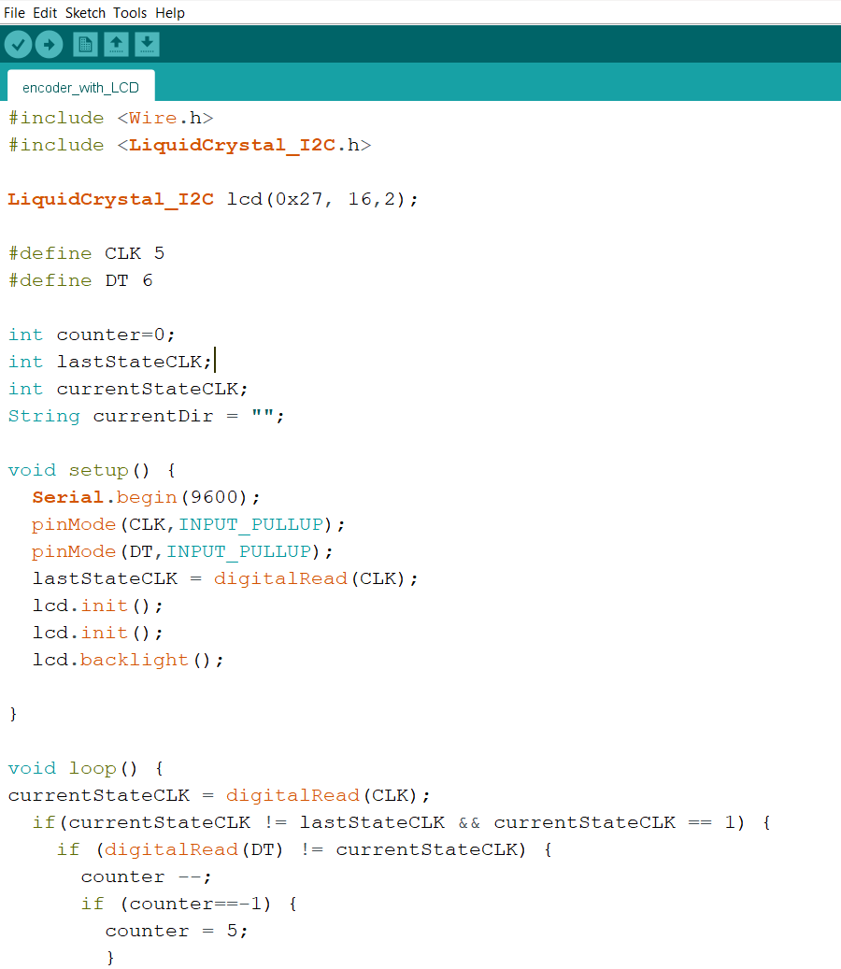

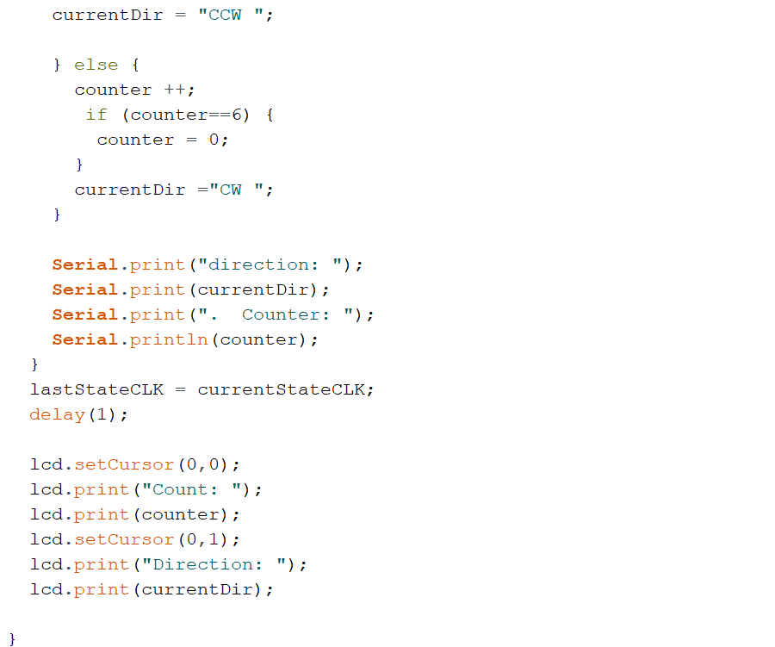



**Arduino UNO Board**

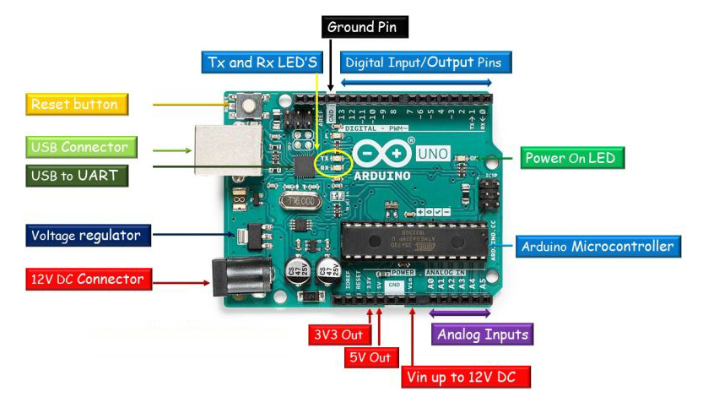

* PWM output pins 3 , 5 , 6 , 9 , 10 , 11
* PWM input pins 2 , 3

**Digital Input/Output Pins**

The Arduino Uno board has 14 digital input/output (1/0) pins labeled from 0 to 13. These 14

pins can be configured as either digital inputs or digital outputs. Out of 14 pins, 6 pins can be

used as PWM (Pulse Width Modulation) output pins and 2 can be used as PWM (Pulse Width

Modulation) input pins. PWM out pins are 3, 5, 6, 9, 10, and 11 and PWM in pins are 2 and 3.

**Analog Input Pins**

The Arduino Uno board provides 6 analogue input pins labelled from Al to A5. These pins are

useful for reading values from sensors, such as temperature sensors, light sensors, and

potentiometers.

Voltage Regulator It controls the voltage provided to the microcontroller and other onboard

components.

**Microcontroller**

This is the main controller IC on which Arduino Code is stored. It is Atmel ATMEGA328P

microcontroller. It is the Brain of the Arduino Board, When Arduino board is powered up it

executes the instructions stored in its 32KB flash memory.

USB Connector A USB connector allows users to connect it directly to a computer or other

devices for programming and communication. It serves multiple purposes. Firstly, it provides

a means to power the board during development and testing phases. Secondly, the USB

connection allows users to upload code to the board and facilitates serial communication

between the Arduino Uno and the computer, allowing data exchange and debugging.

**Arduino Uno Board Specifications**

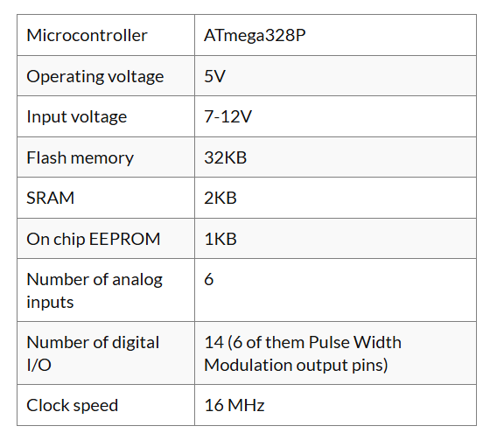

The Arduino Uno uses the ATmega328P microcontroller,

which has three types of memory:

Flash Memory (ROM) - Stores the program/code (non-volatile)

SRAM (RAM) - Stores temporary data (volatile)

EEPROM - Stores data permanently, even after power is off

✓ Flash Memory (ROM): Stores your program code permanently.

✓ SRAM (RAM): Stores variables during program execution (limited!).

✓ EEPROM: Stores user data/settings permanently.

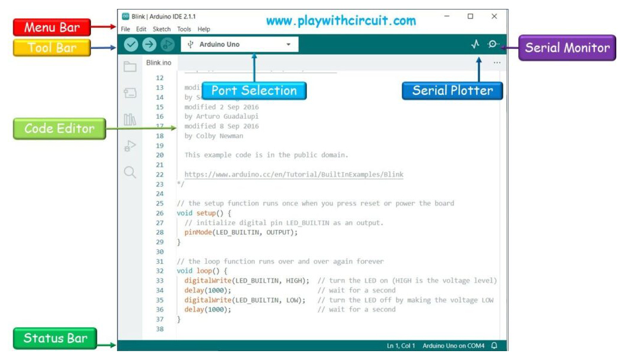

**Logical operators**

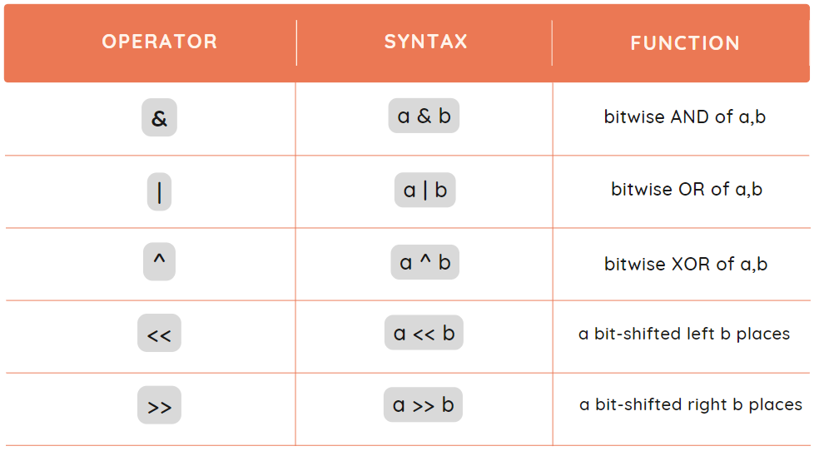

1. **For Loop -**

* A for loop is a loop that is used to perform an action a specified number of times.

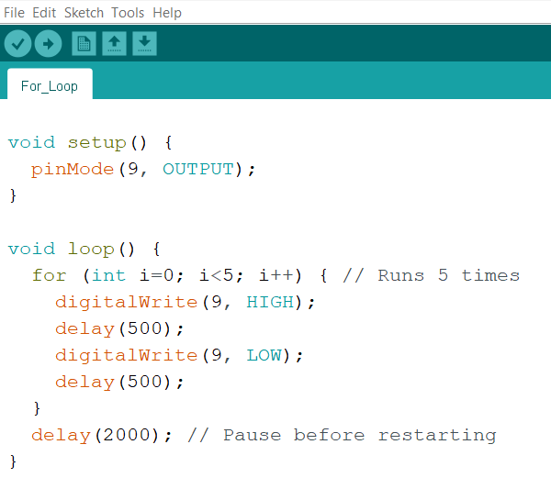



2. **While Loop -**

* A while loop repeats a block of code while a specific condition remains true.

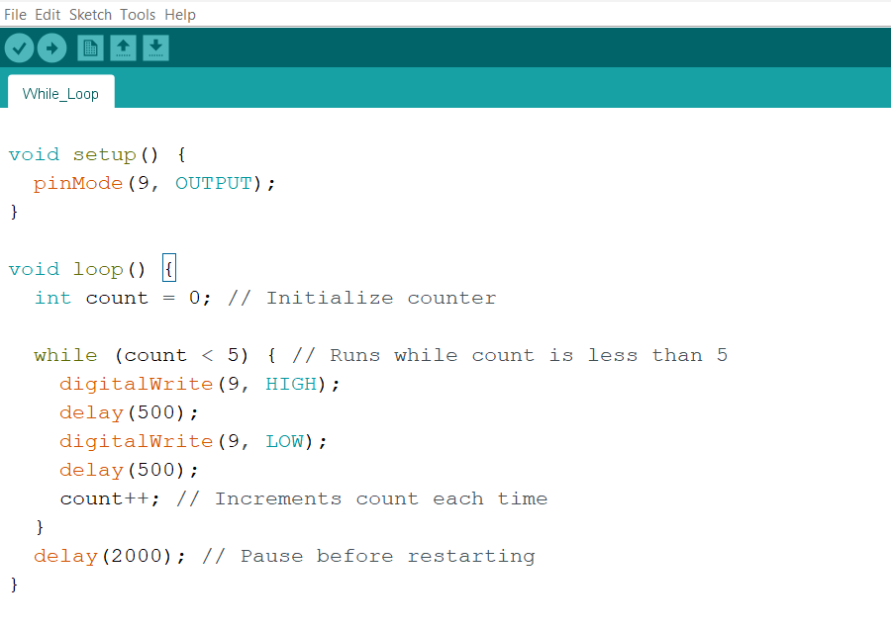



**Electrically Erasable Programmable Read-Only Memory (EEPROM)**

* EEPROM is a type of non-volatile memory.

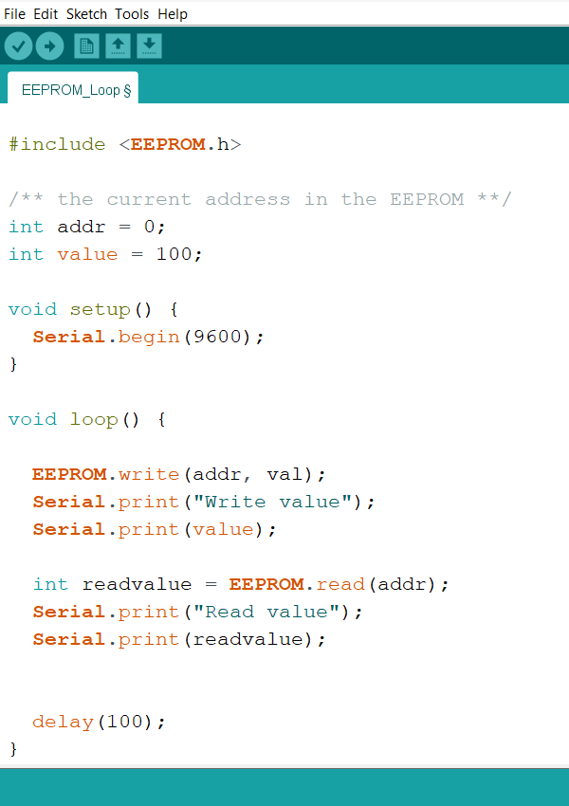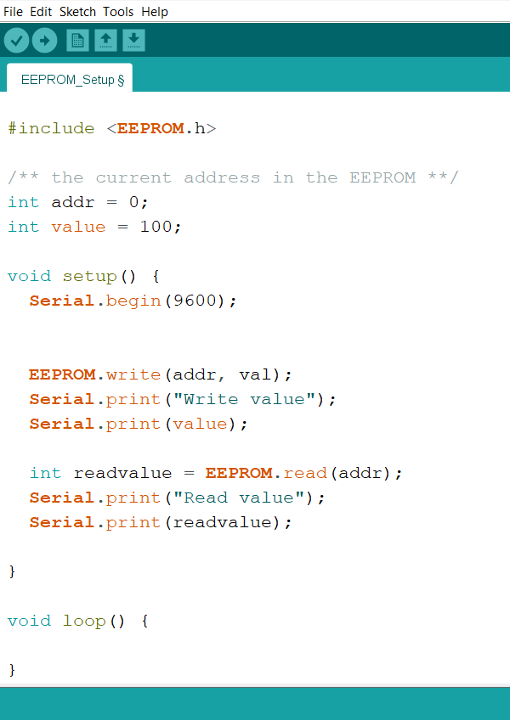

**Gyroscope Module**

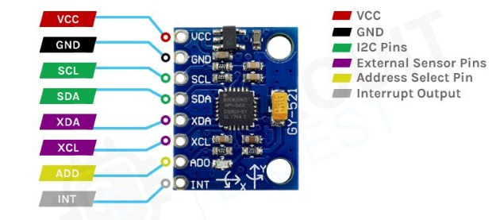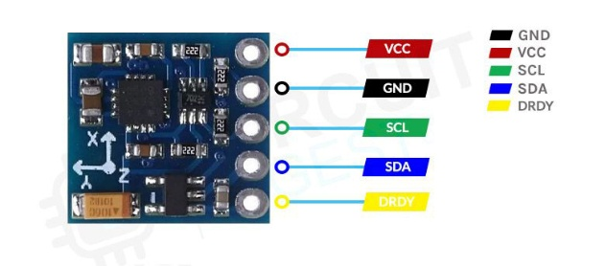

* Gyroscope module is a device that can measure and maintain the orientation and angular

velocity of an object. It is more advanced than an accelerometer, which can only measure

linear motion. 3-axis gyroscopes measure angular rate and are usually combined with an

accelerometer in a common package to allow advanced algorithms like sensor fusion.

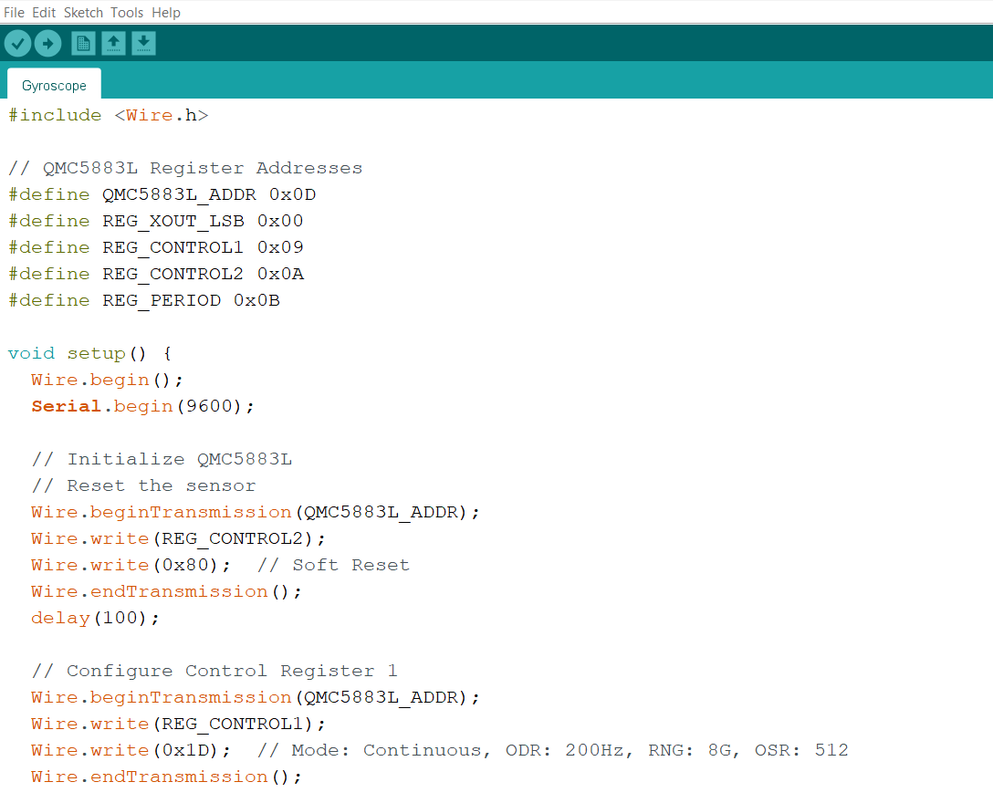

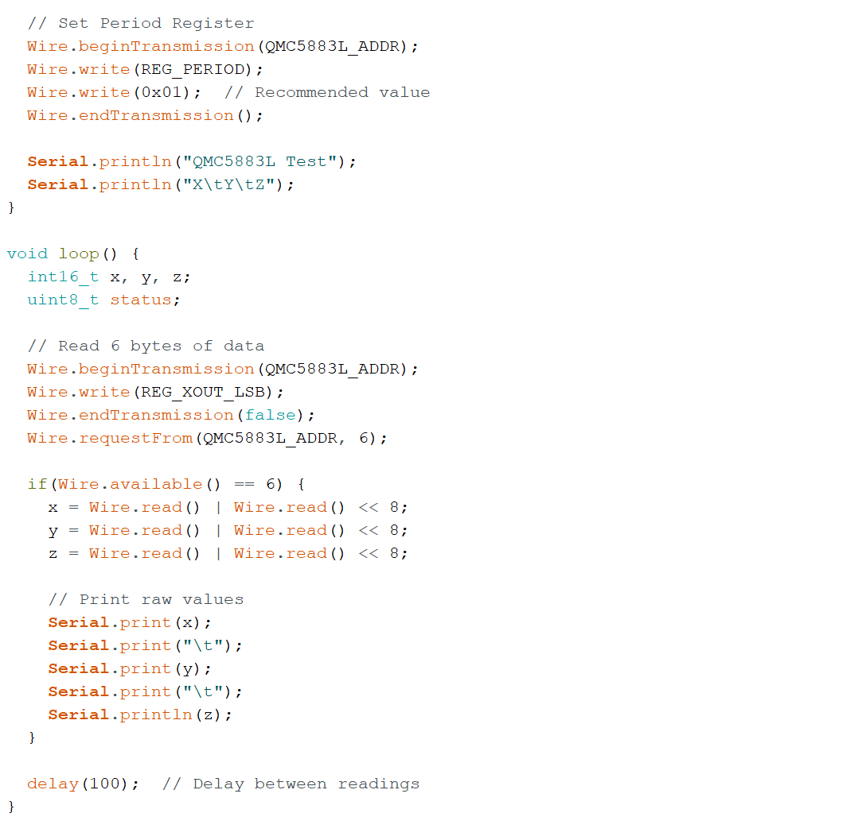



**Load Cell Sensor**

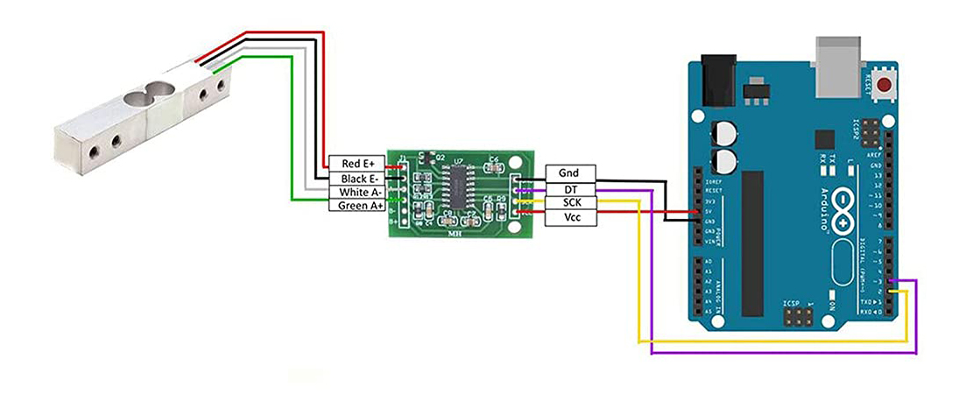

* load cell is a sensor used to measure force or weight. It converts mechanical force into an

electrical signal. Load cells are commonly used in various applications where force, weight,

or tension measurement is required.

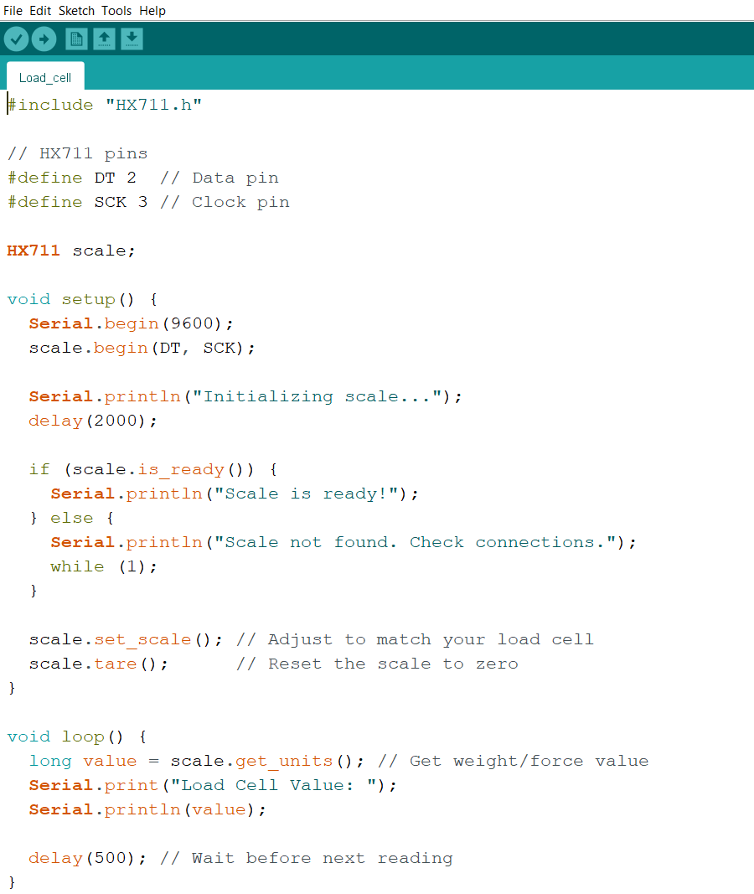



**Real-Time Clock Module (RTC)**

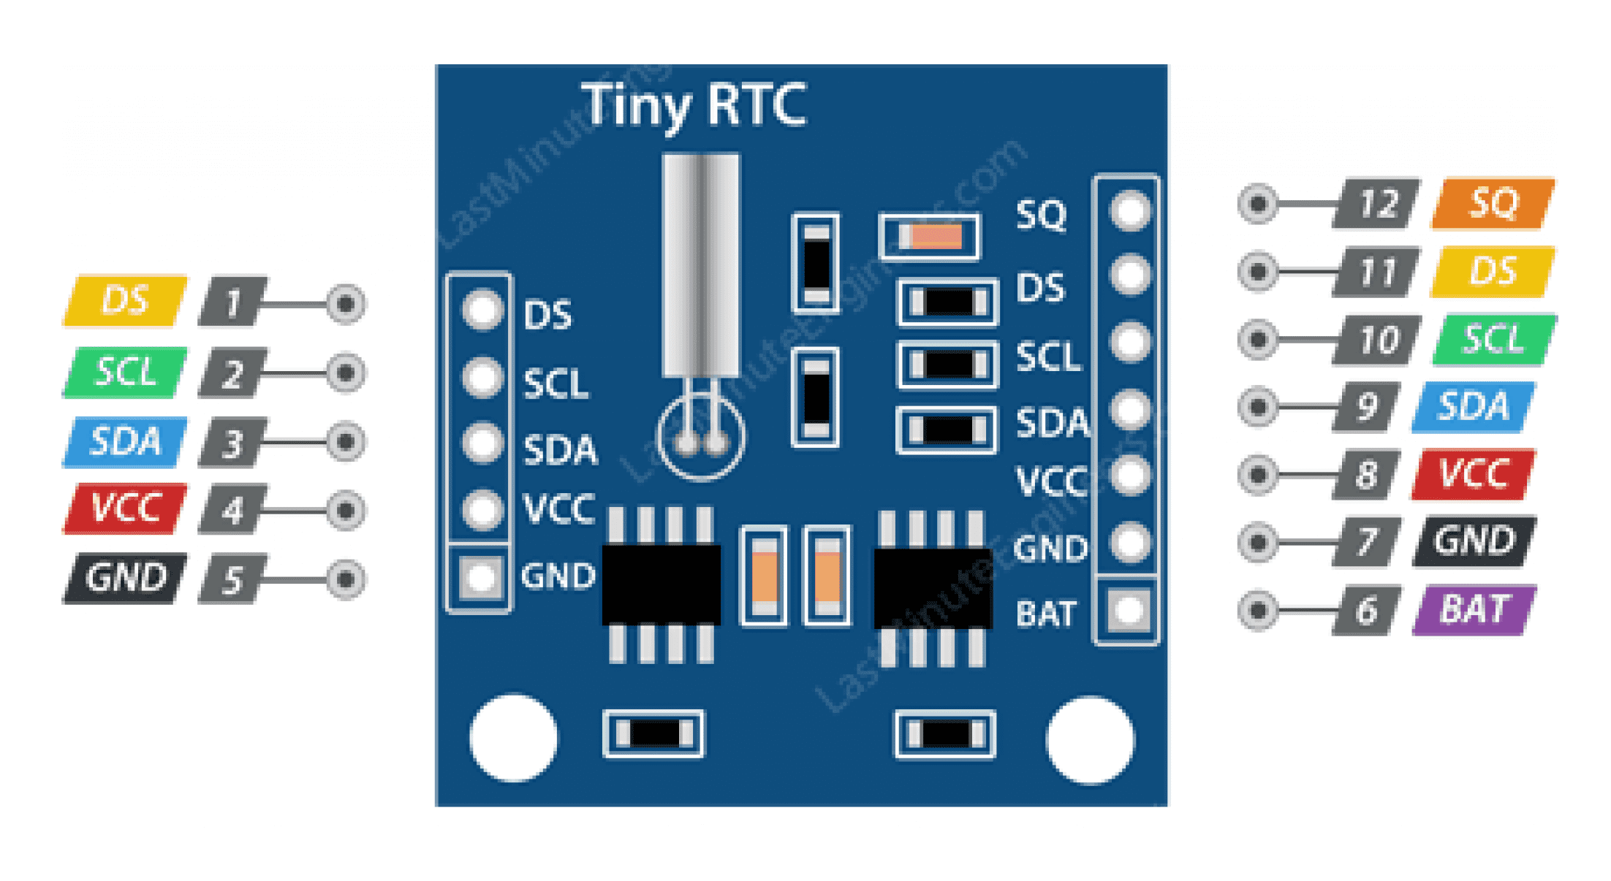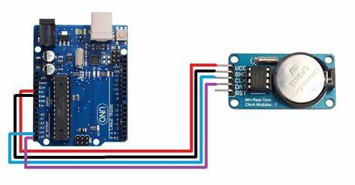

* RTC module is an integrated circuit clock module that provides timekeeping.

It can count seconds, minutes, hours, and years. The module ensures a constant

reference to the current date and time, even during power outages.

